

OneLink Access Request
Access Request

Request OneLink Role in AccessNow
Step # | Description | Screen
Step 1.1 | Navigate to the AccessNow Login Page (formerly KPIM).  Enter NUID and Password Credentials | 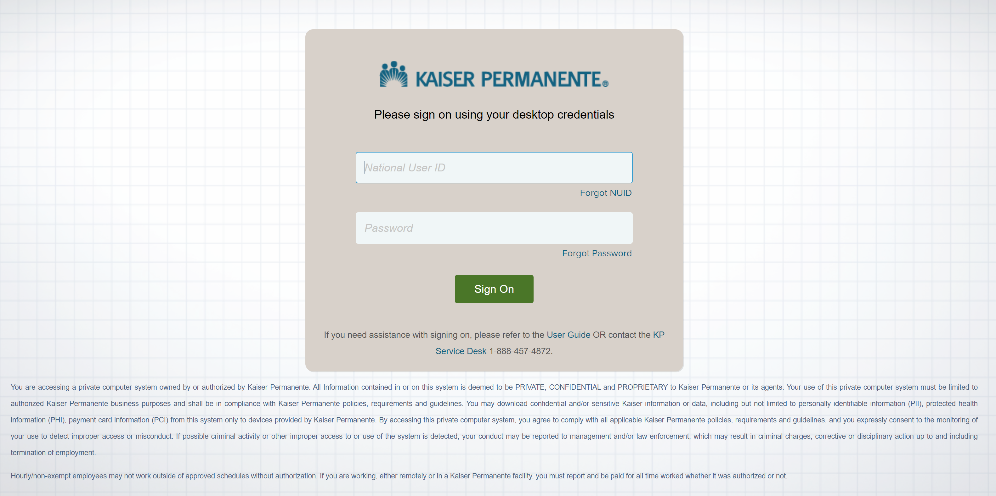
Step 1.2 | From the AccessNow home page, click the icon with three lines on the upper left of the screen.  Click Manage Access from the drop-down options.  Then click Manage Access for Others from the drop-down list. | 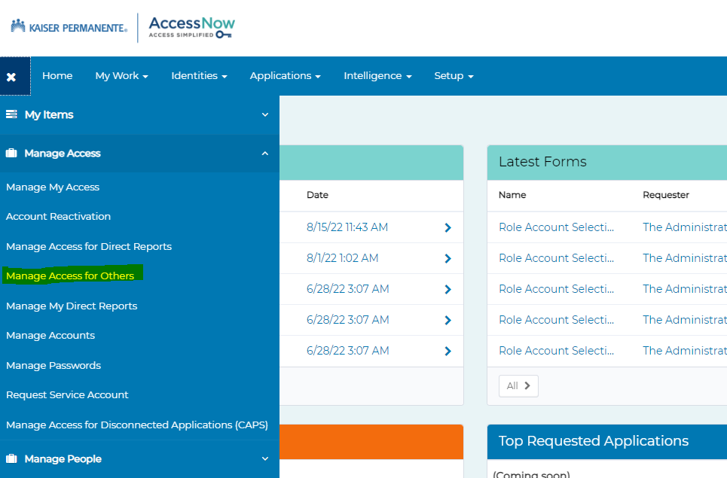
Step 1.3 | Search for the user with NUID or Name select the user and click on Next | 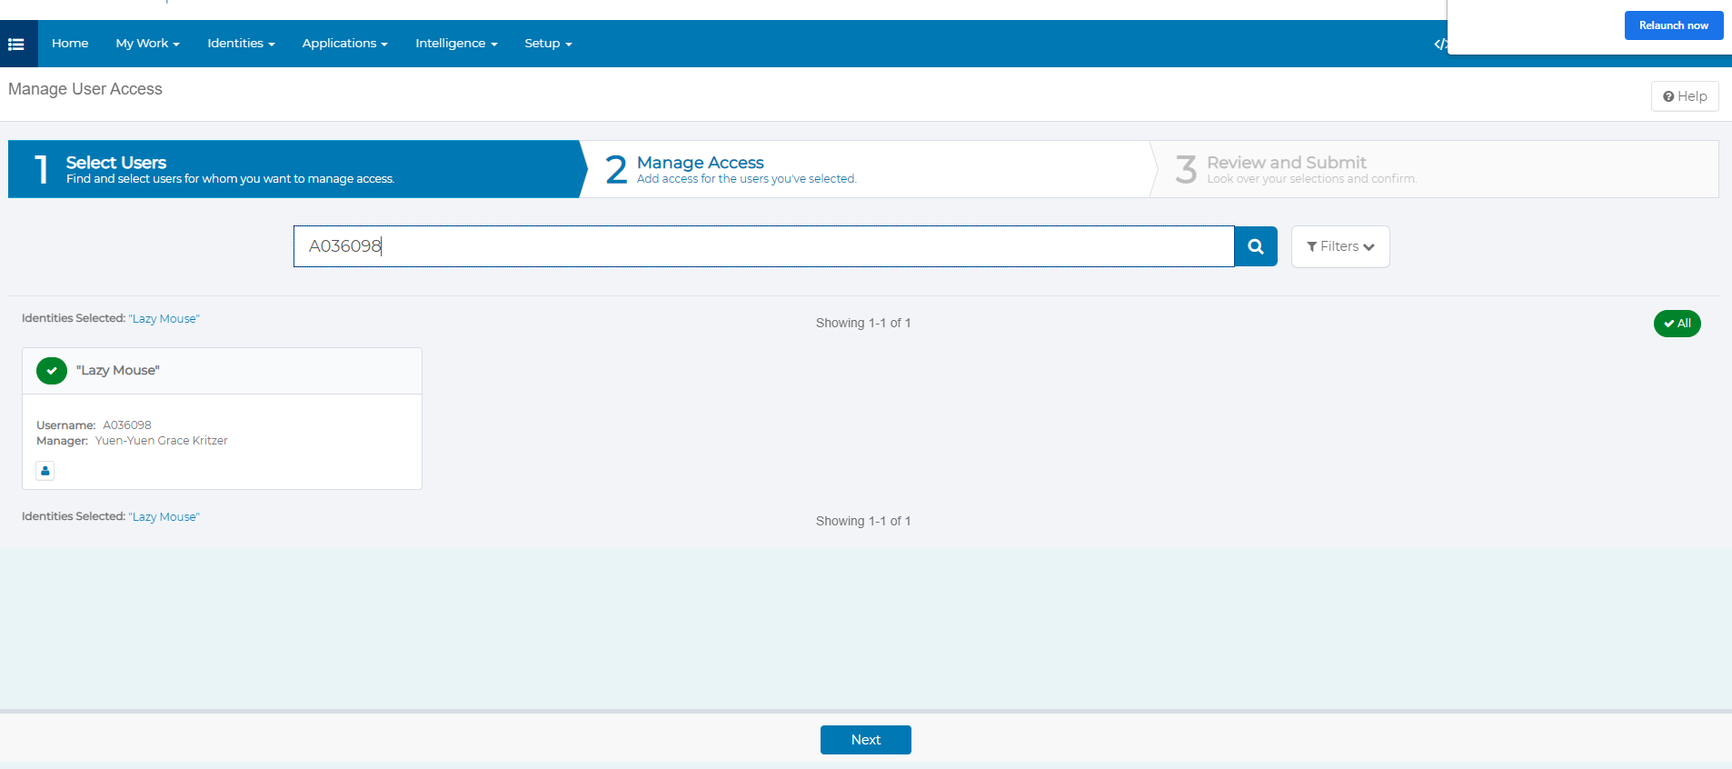
Step 1.4 | Search for “OneLink Access” and click on Filters select Role Type “Business” and click on apply.  It will show you one role, select the role, and click on Next. | 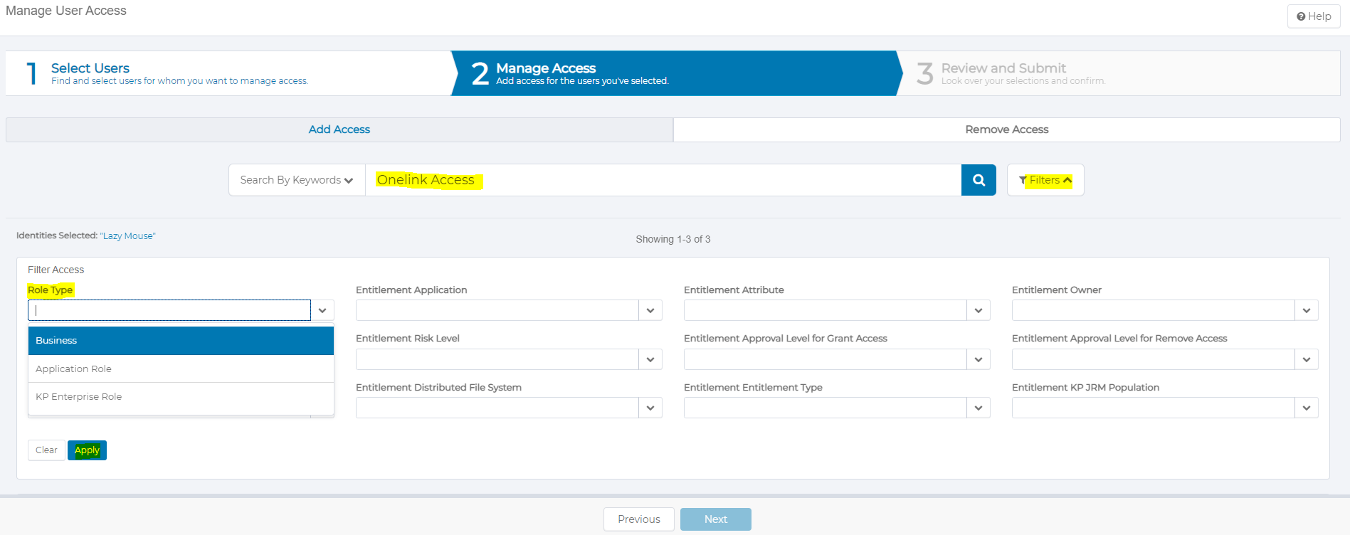  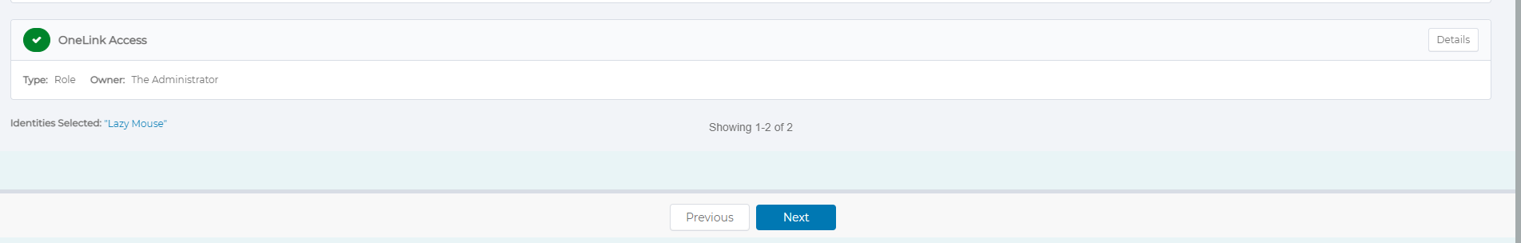
Step 1.5 | Click on attachment icon to upload attachment for your request if desired. | 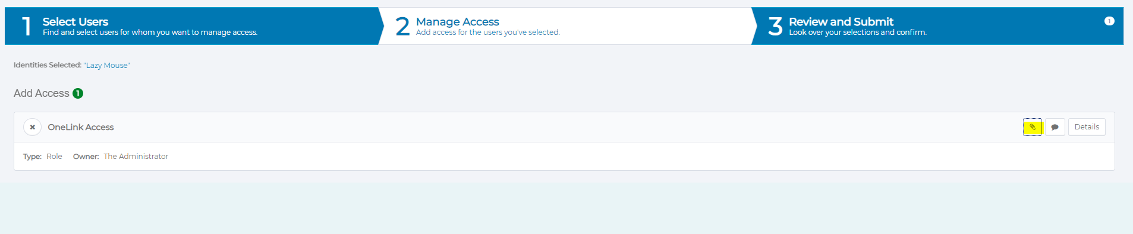  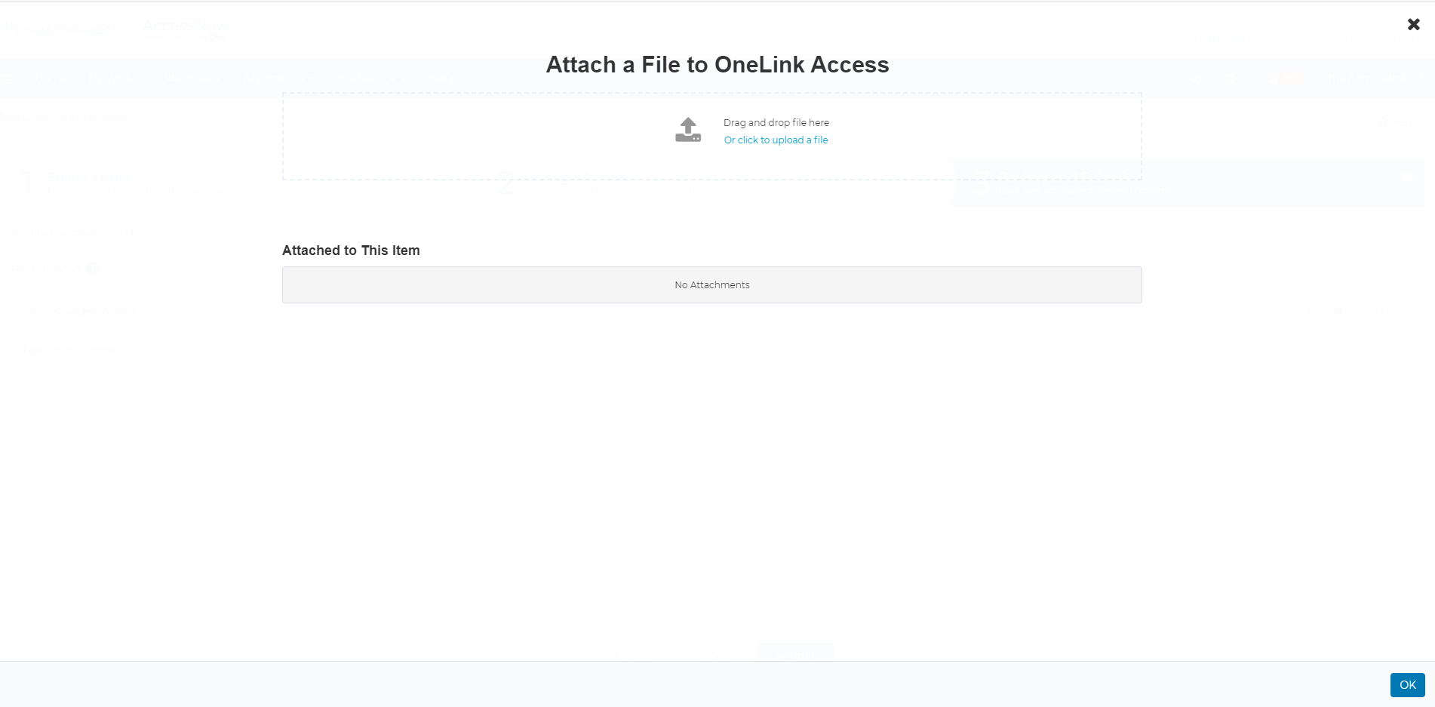
Step 1.6 | If you wish to attach a file, then click on “Click to upload a file” to select the file or you can drag and drop the file. | 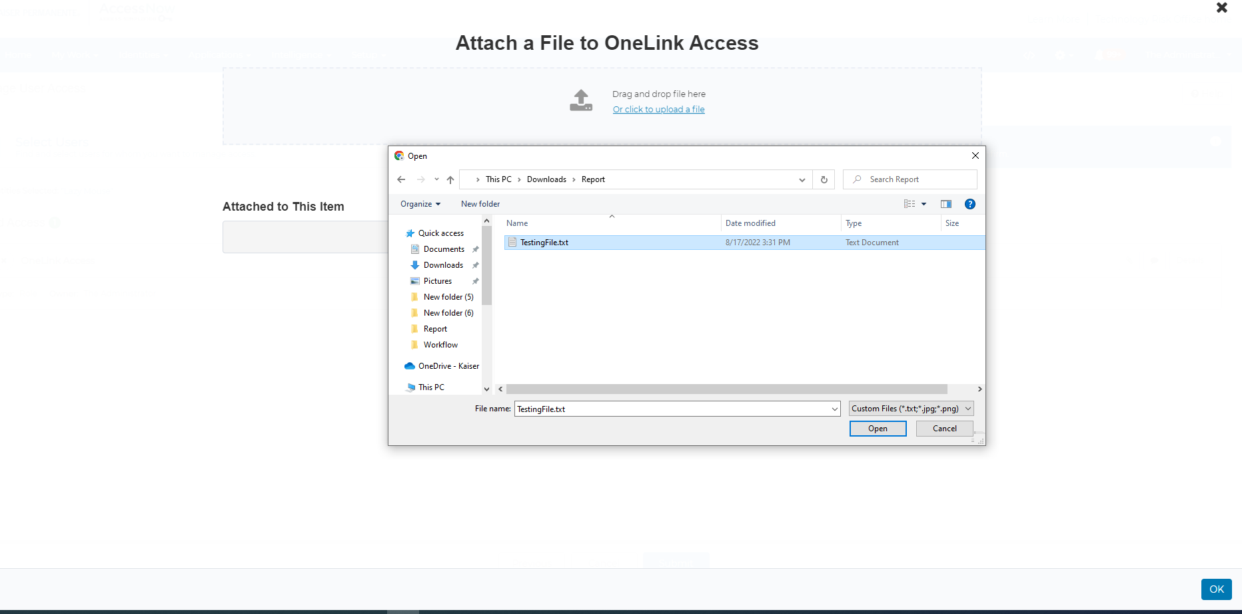
Step 1.7 | You can enter description and delete the uploaded file. Once you are ready click ok. | 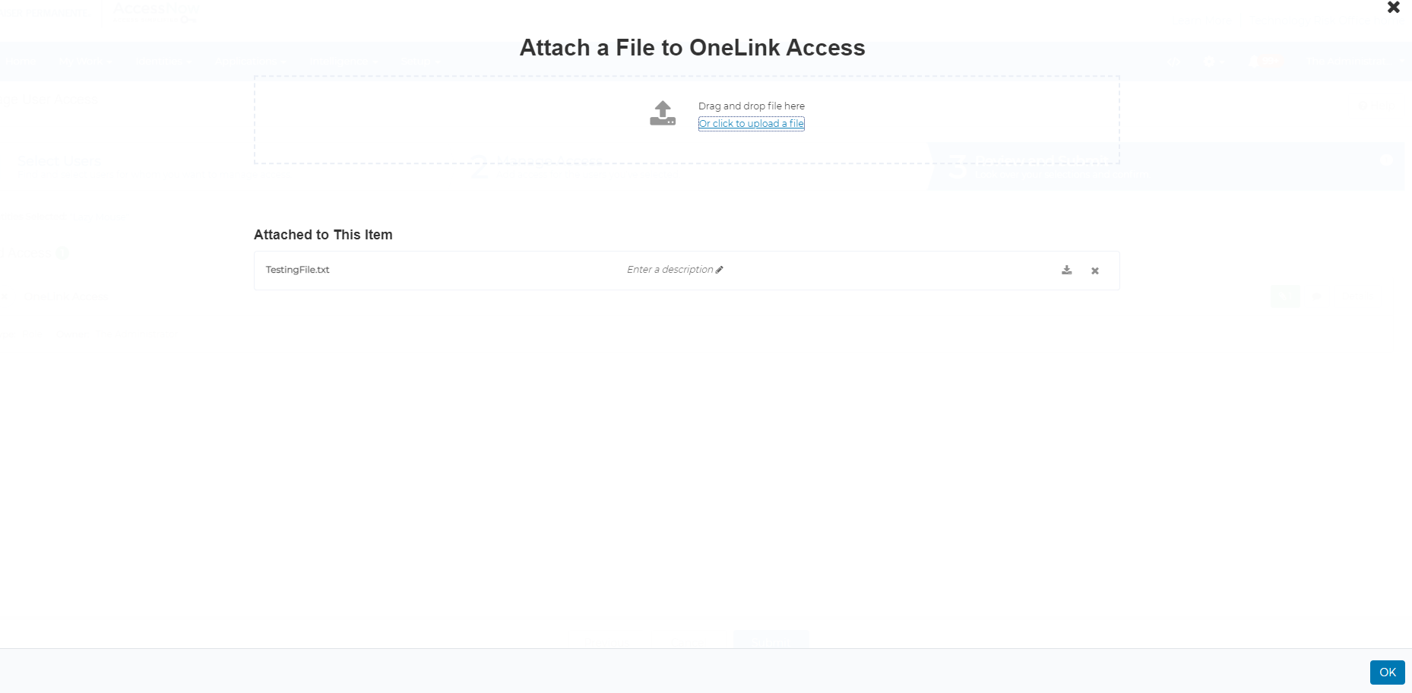
Step 1.8 | Click on submit to submit the request. | 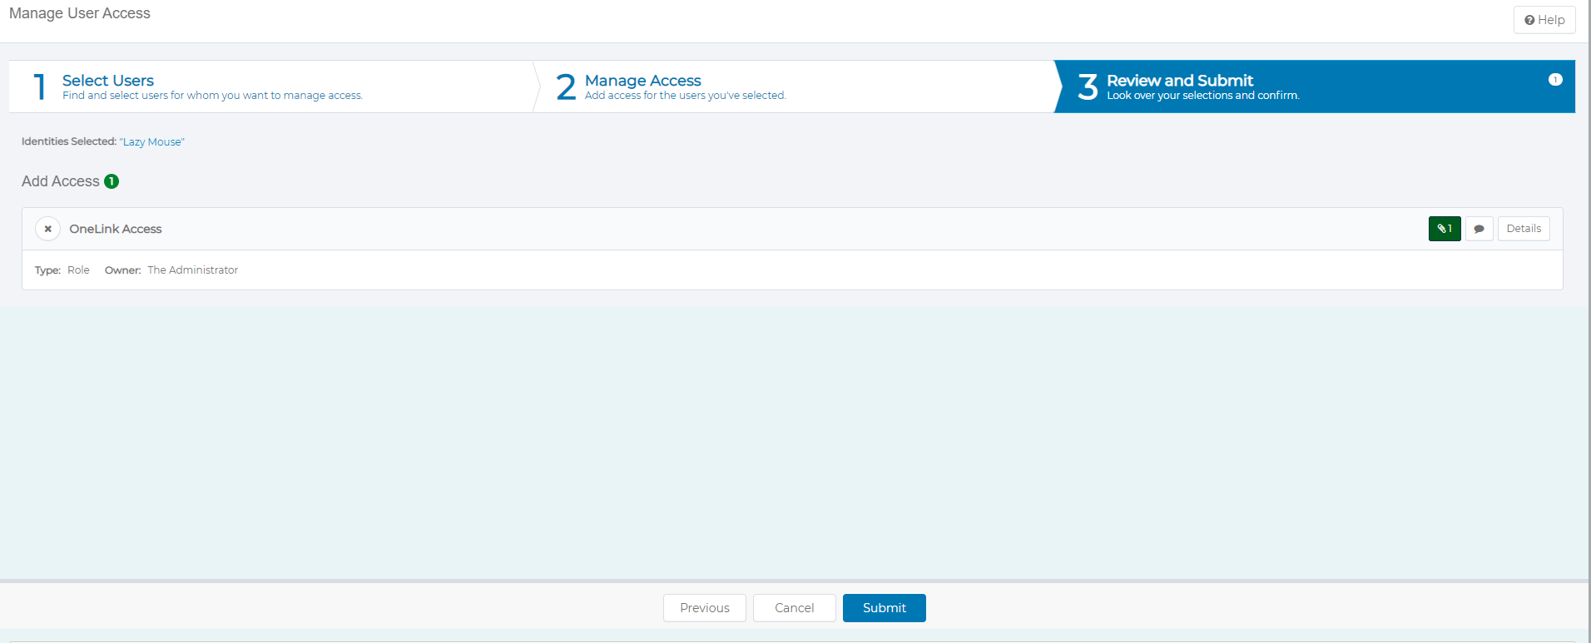
Step 1.9 | A window will appear entitled. “More info needed” Click on the “Complete Form” button to proceed. | 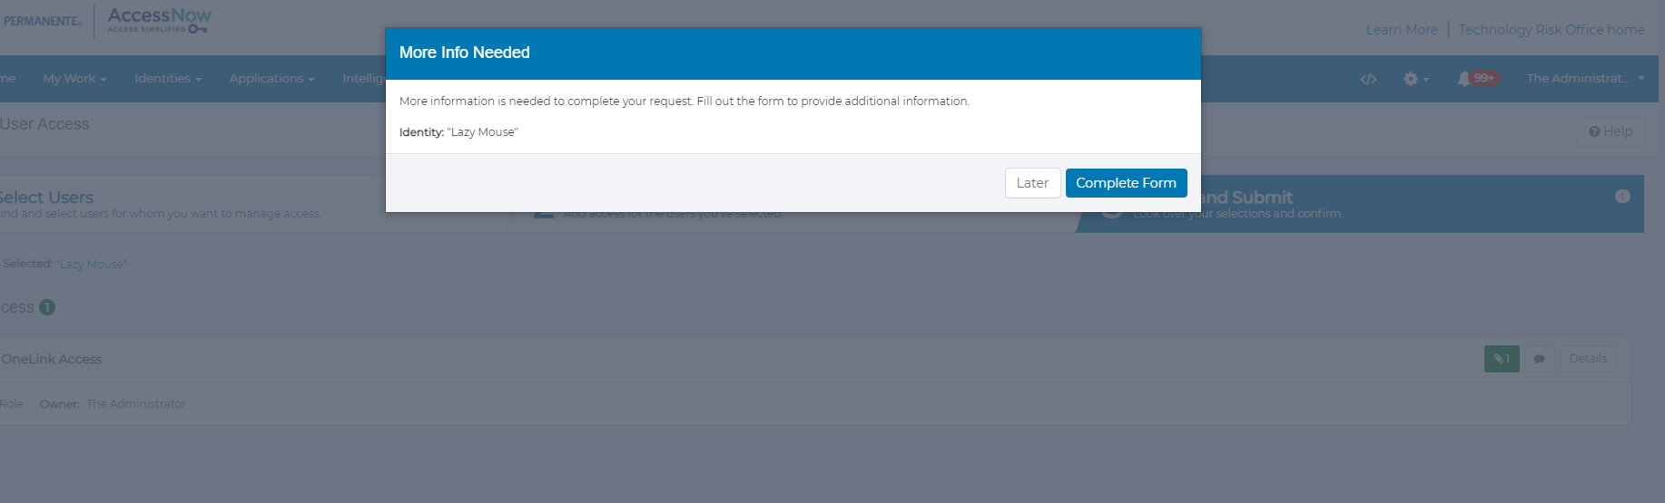
Step 2.0 | Once you click on the “Complete form” buttons, request form details will be displayed on the subsequent window. | 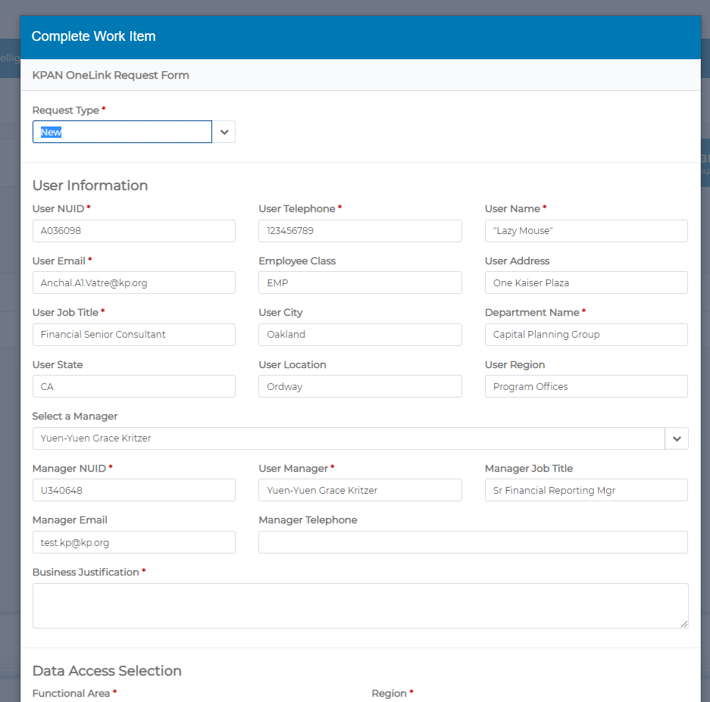
Step 2.1 | User information will be prepopulated if available within AccessNow. If not, mandatory fields marked with a red asterisk must be manually populated with data to proceed further.  If manager information isn’t prepopulated or if the manager shown is not appropriate, please select the appropriate manager. Note, that only valid mangers with direct reports will be available in the drop down.  Enter an appropriate Business Justification in the “Business Justification” field. | 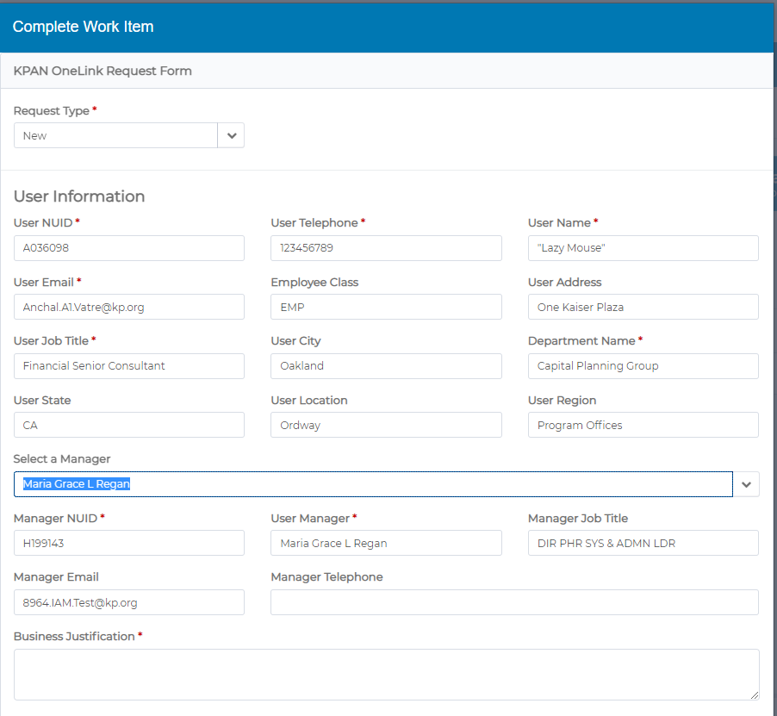
Step 2.2 | Data access selection:  Functional Area, Region, Service Area, and business unit are required fields and dynamic fields. They change based your previous selections.  Check on the Add Primary permission List checkbox to add the Primary Permission list and approvers. | 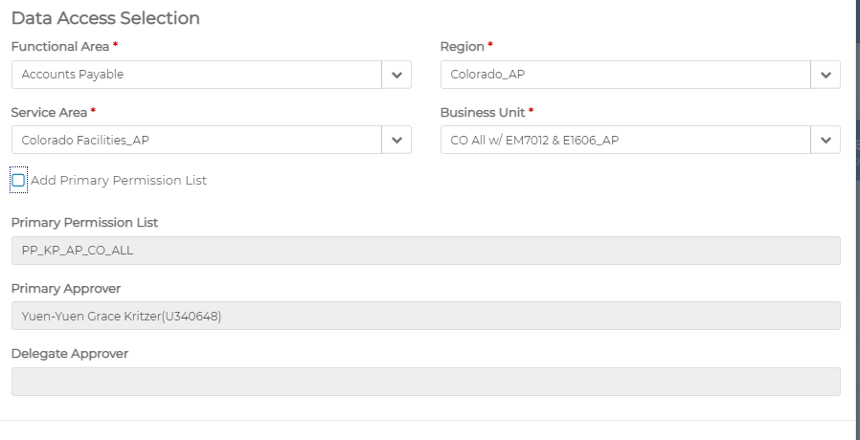
Step 2.3 | Primary job functions:  This is also a mandatory field and dynamic field. The values will be changes based on your previous selections.  Select the primary job function from the drop-down list and click on check box “Insert Job function. Note that multiple primary job functions may be selected in this manner. | 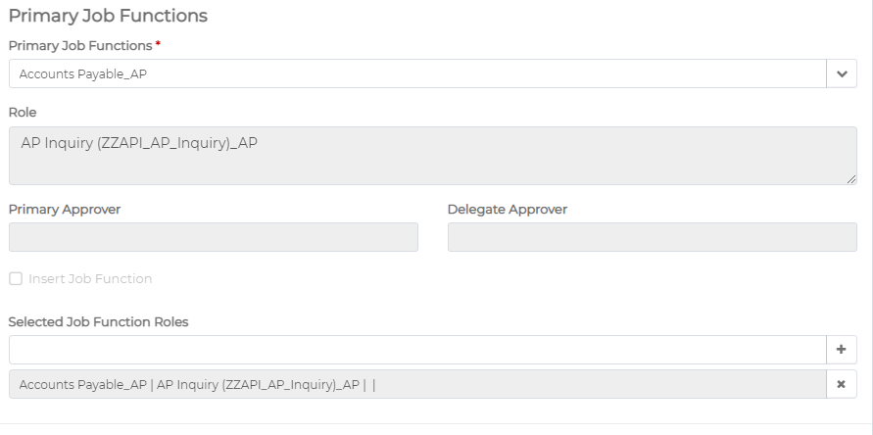
Step 2.4 | Additional roles can be added from the Additional roles section and use the Add or Remove radio button to indicate operation type. Click on the “Insert Roles” checkbox once you’ve made selection and multiple selections can be made using this procedure. | 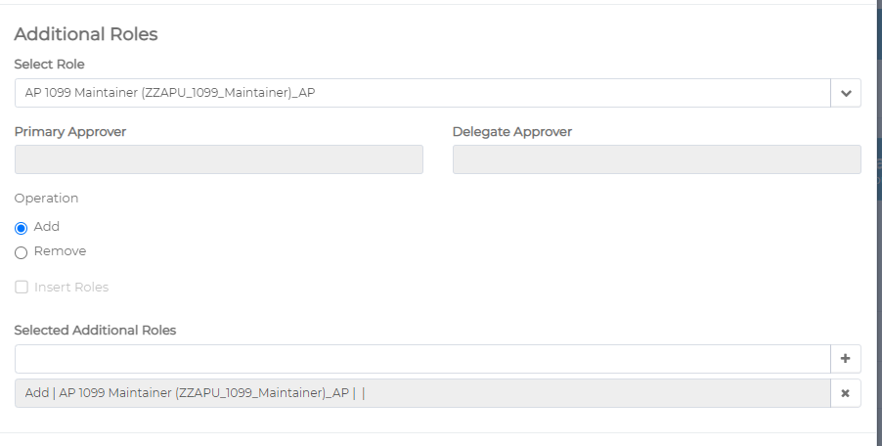
Step 2.5 | Multiple additional roles can you added from the dropdown list. | 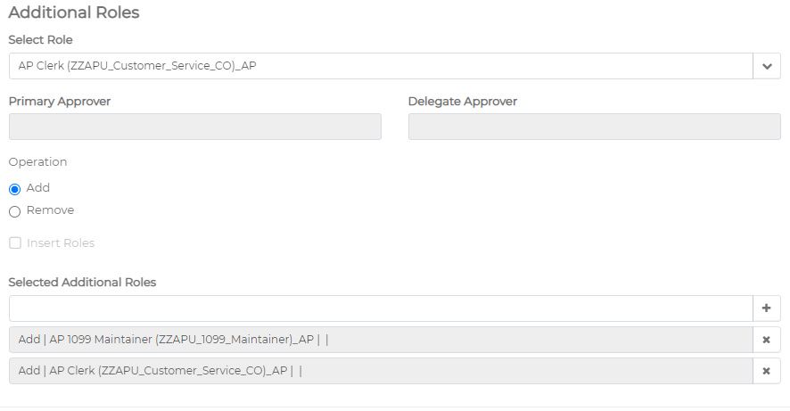
Step 2.6 | If you wish to remove selected additional role you can click on the cross mark next to the selected additional role name. | 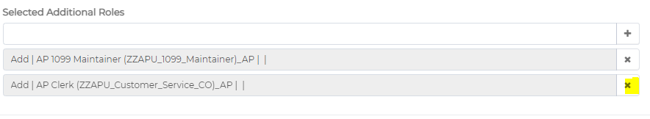
Step 2.7 | If there are any segregation of duties will be show in the Migrating control of segregation of duties section this is a read only section. | 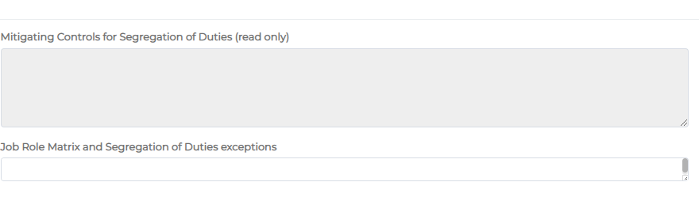
Step 2.8 | Additional comments can be added to your request from “Additional comment” section. | 
Step 2.9 | Click on next to proceed. If any fields need to be corrected either because of missing data or incorrectly formatted entries, an error message will be displayed indicating that you must correct the flagged entry before proceeding. | 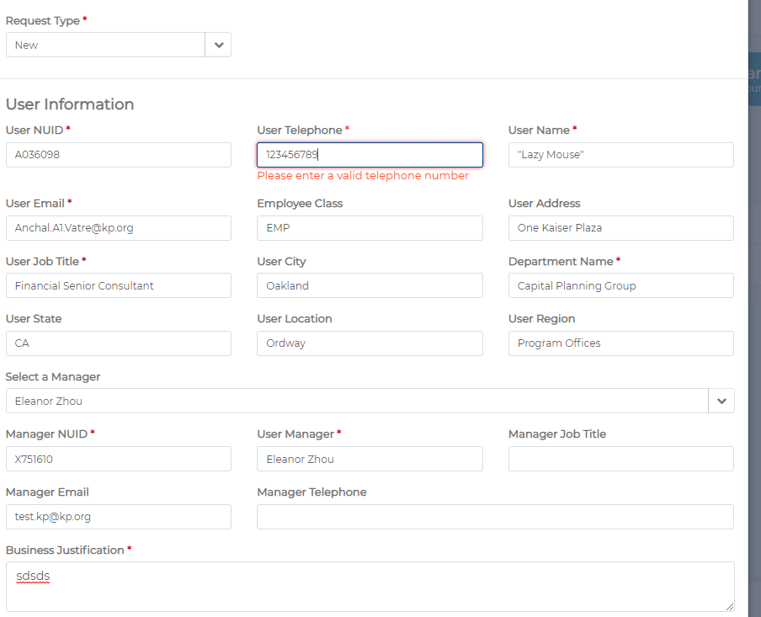
Step 3.0 | Preview form:  If all the entered details are correct and request field are filled, then it will show you a preview form. You can validate entered details/ requested roles. You can continue by clicking “Submit” or you can click on “Back” button to go back to the form and make changes. Clicking on Cancel will terminate the request. | 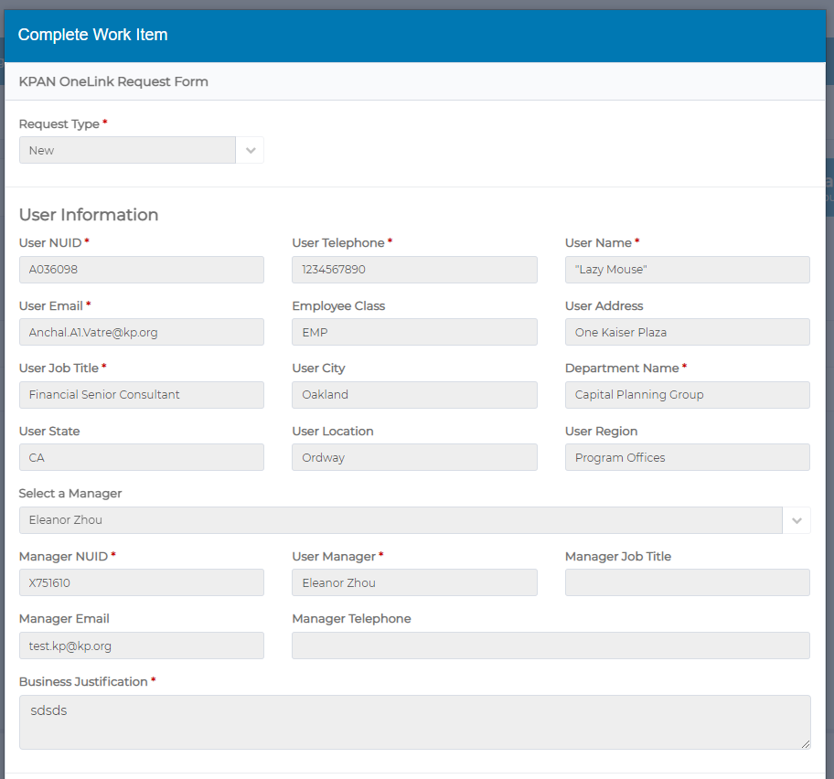  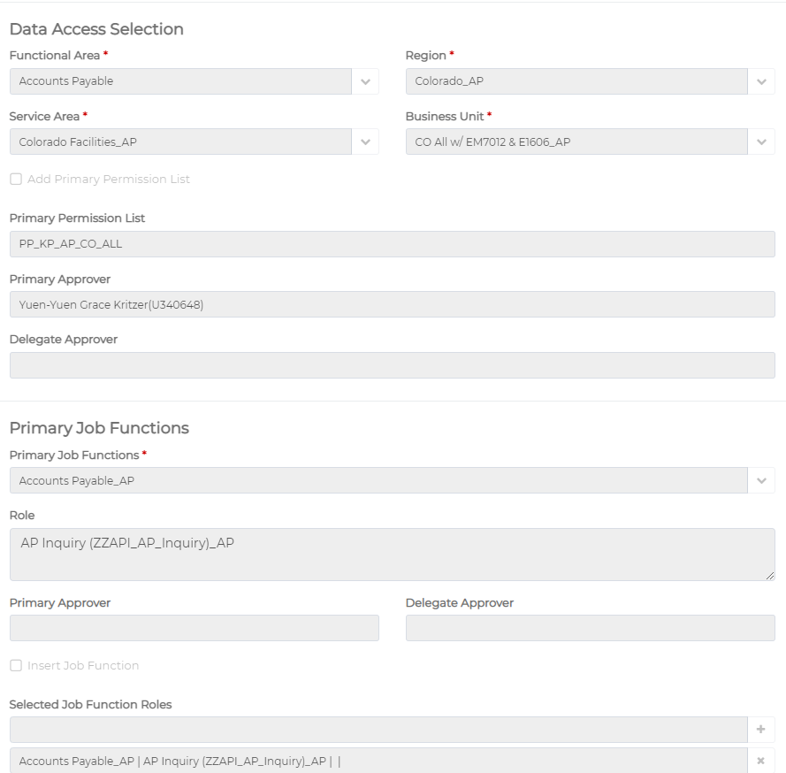  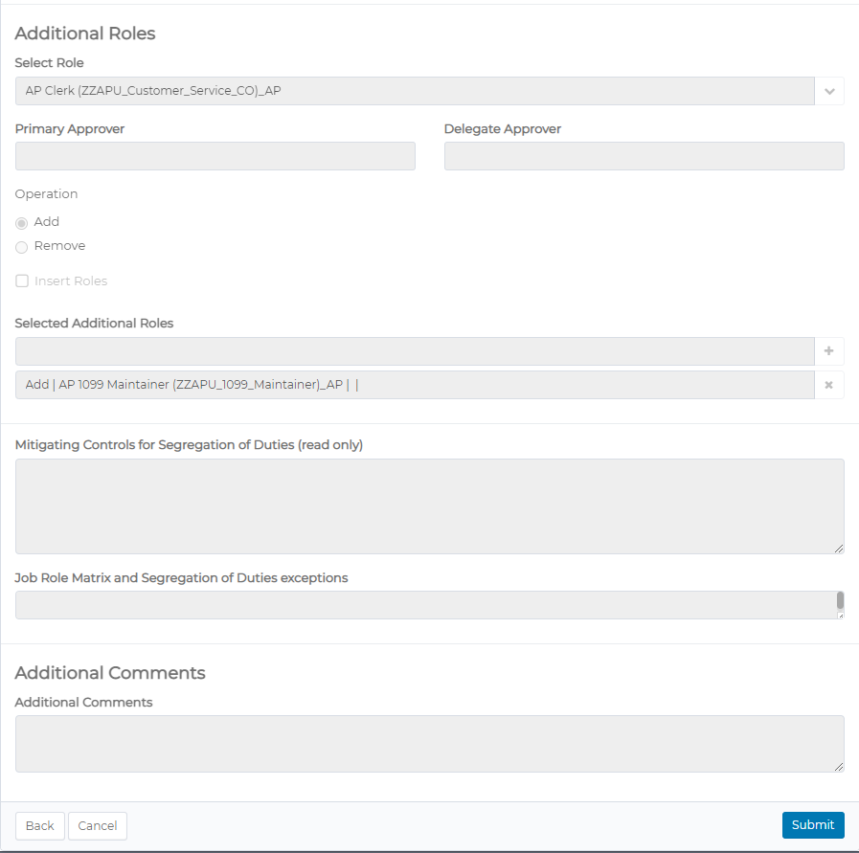
Step 3.1 | If you click on Submit, the request will be submitted, and it will show you a confirmation message.  Click on “ok” to complete the request. | 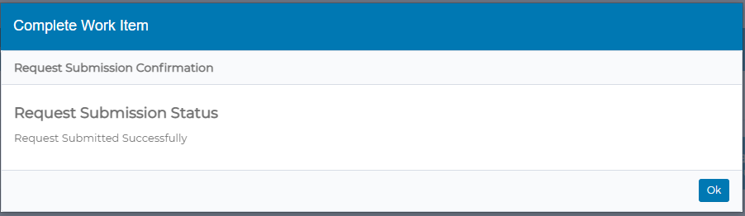
Step 3.2 | If you got My Work and Access Requests, you could check the status of your requests. | 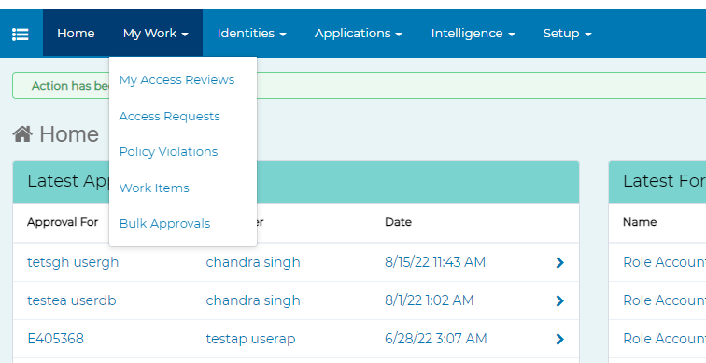  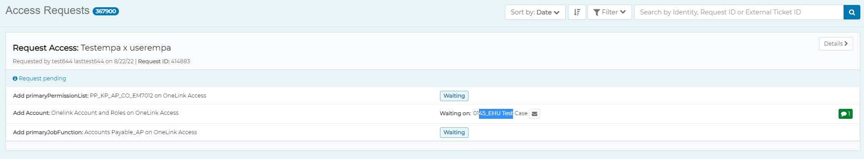
Step 3.3 | AccessNow will also send an email to you as confirmation that your request has been submitted | 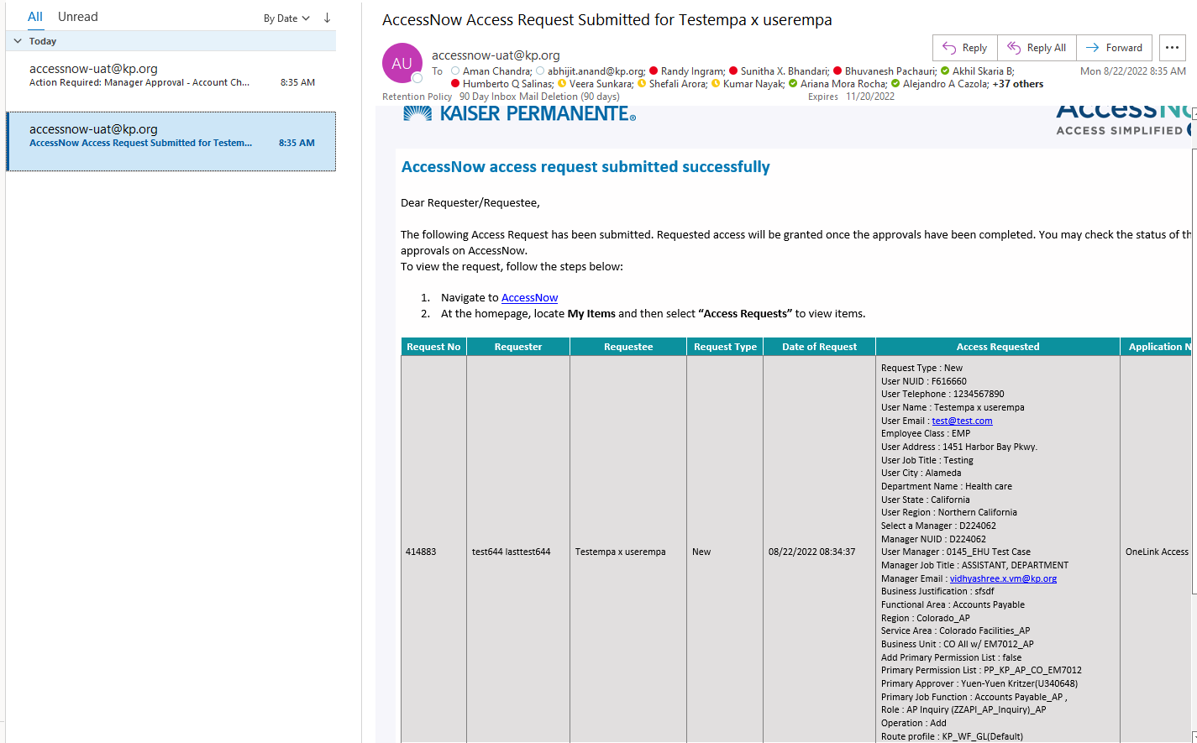
Step 3.4 | If the requester is not the same person as the manager, AccessNow will send an approval work item to approve the request along with an email notification | 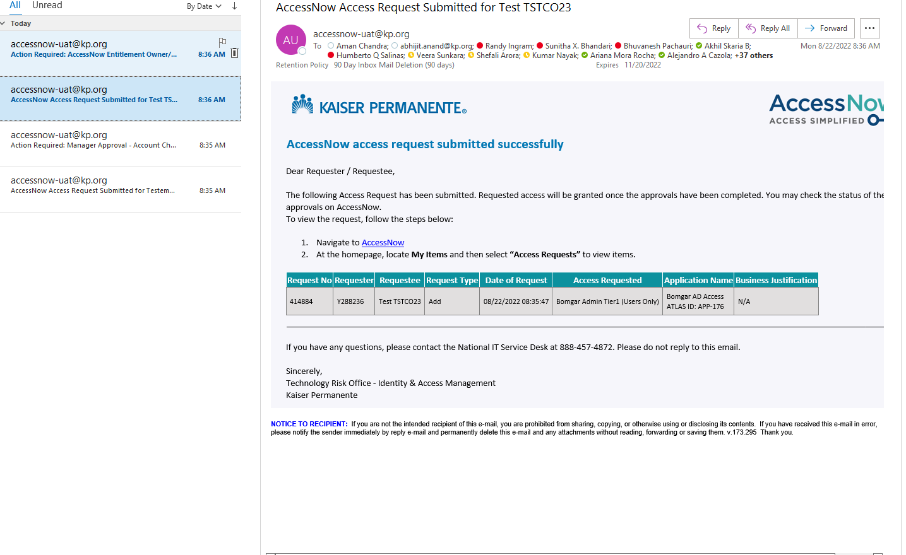  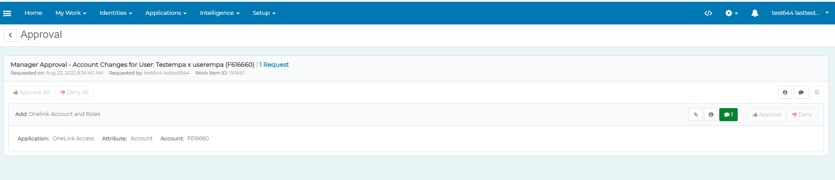
Step 3.5 | Manager Approval:  Manager will login with his/her credentials and click on Approve to approve the request and “Complete” to complete the workitem.  In order to approve the request, however, comments are mandatory. Manager can add comments by clicking the message icon on the approval item | 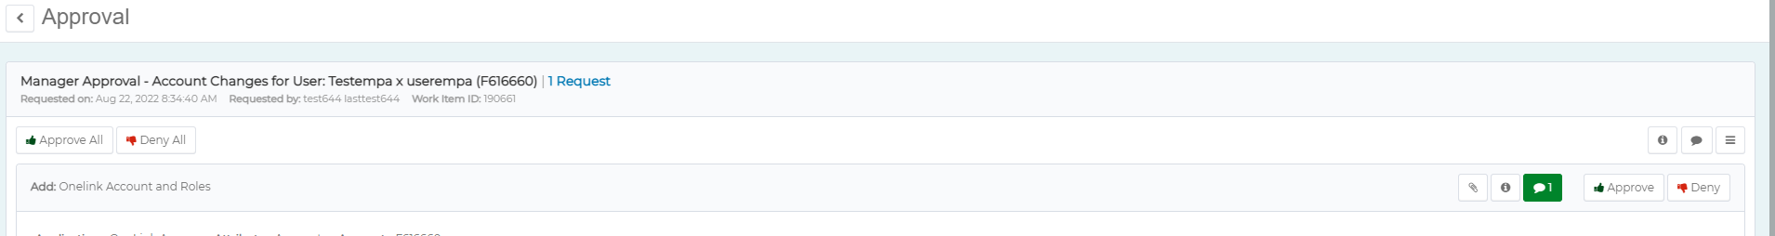  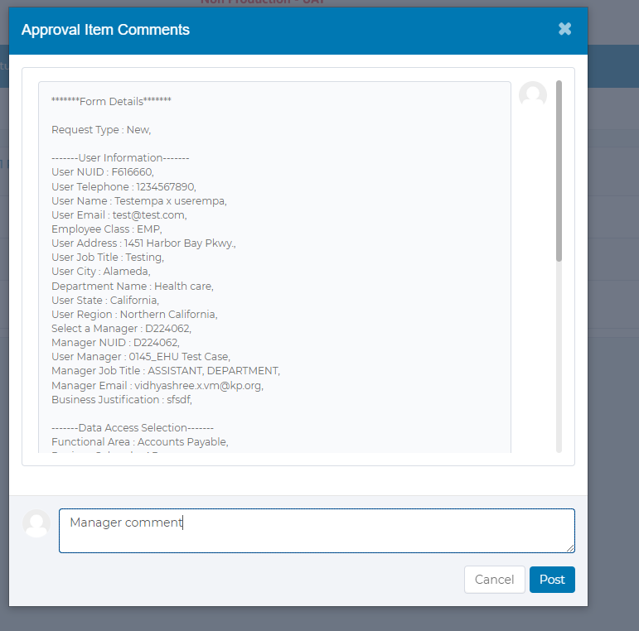  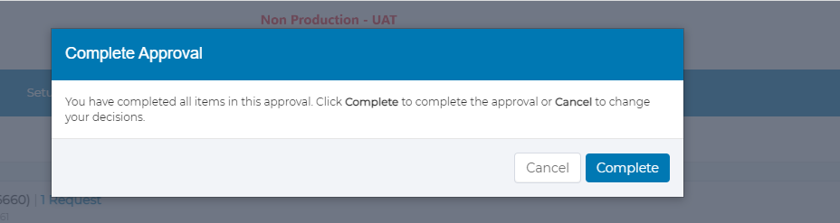
Step 3.5a | Manager approval: Checking User’s existing OneLink access. | Before approving access, you can check to see if any the user’s existing access conflicts with the request by utilizing one of the following OneLink  To access queries, navigate to the “Reporting” tile on the OneLink Home page:  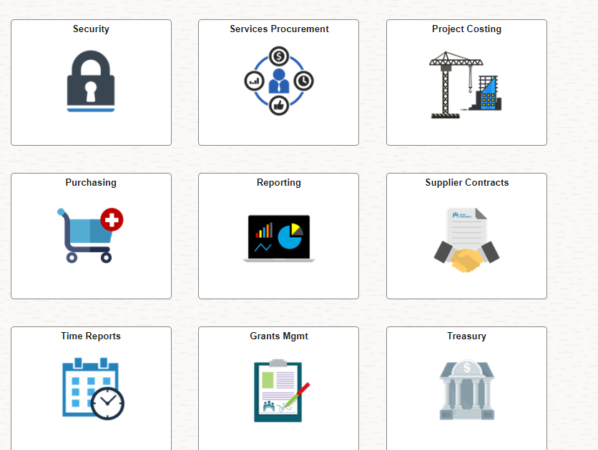  After clicking on the “Reporting” tile, select “Query Viewer”  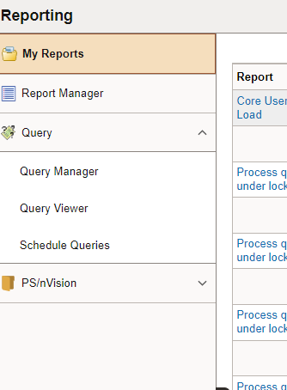  After clicking on “Query Viewer”, type or paste the appropriate query name from the following:  KP_SEC_USER_PPL_AND_ROLES  Shows what primary permission list user has along with their roles.  KP_RPT_BU_ACCESS_FOR_USER  Shows what business units user has access to in their primary permission list  Select the format you’d like to receive the report results in and each query will prompt you for the NUID of the user in question. Results will either be downloaded or displayed on screen depending on what format you chose.
Step 3.6 | Once the manager approval is complete, respective PPL and PJF approvers will be notified along with workitem to approve the request. | 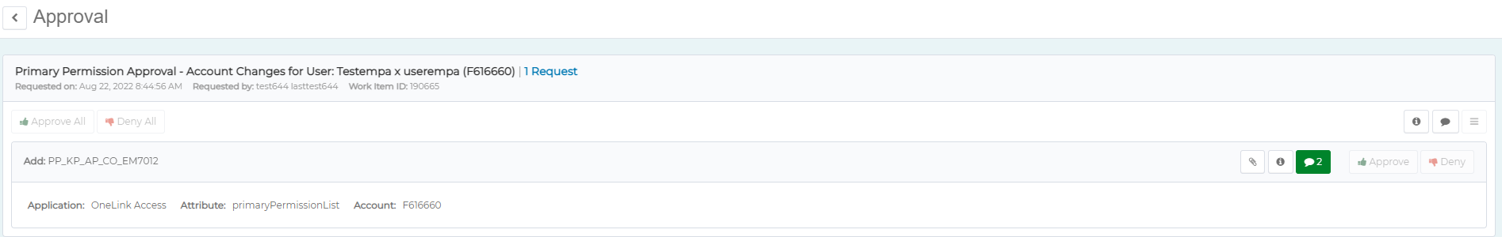  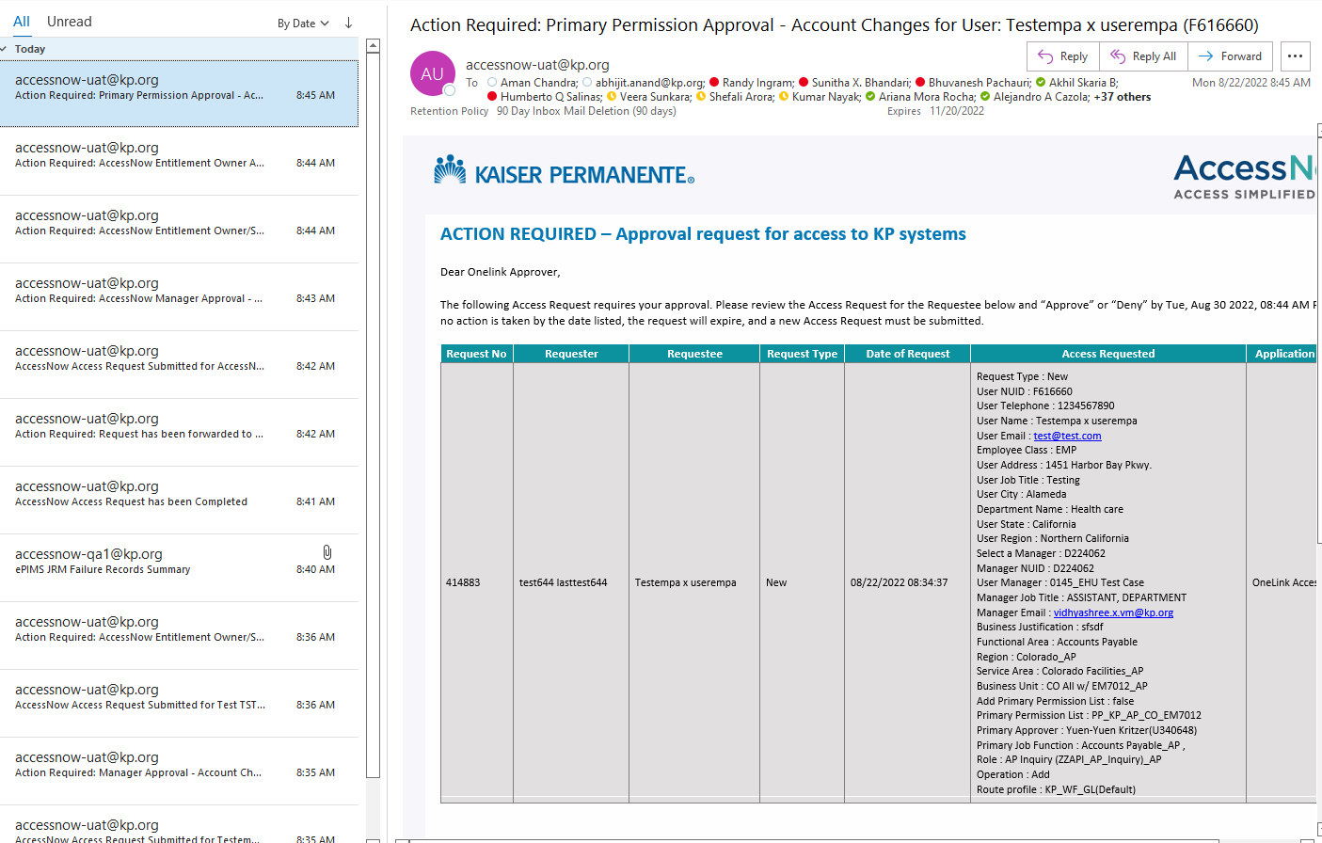
Step 3.7 | PPL and PJF approvers can login and approver the request same as manager. | 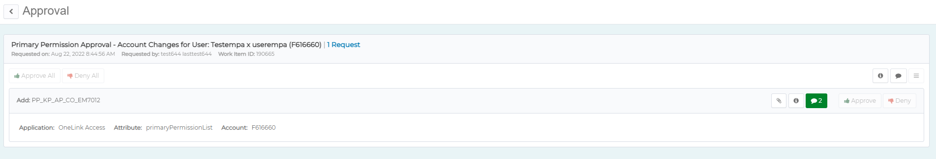
Step 3.7a | Business Process Owner Approval: Check user’s existing OneLink access. | Before approving access, you can check to see if any the user’s existing access conflicts with the request by utilizing one of the following OneLink  To access queries, navigate to the “Reporting” tile on the OneLink Home page:  After clicking on the “Reporting” tile, select “Query Viewer”  After clicking on “Query Viewer”, type or paste the appropriate query name from the following:  KP_SEC_USER_PPL_AND_ROLES  Shows what primary permission list user has along with their roles.  KP_RPT_BU_ACCESS_FOR_USER  Shows what business units user has access to in their primary permission list  Select the format you’d like to receive the report results in and each query will prompt you for the NUID of the user in question. Results will either be downloaded or displayed on screen depending on what format you chose.
Step 3.8 | Once all the requests are completed requester will be notified with an email of completion of request. Additionally, you can view the ServiceNow ticket in the access request. | 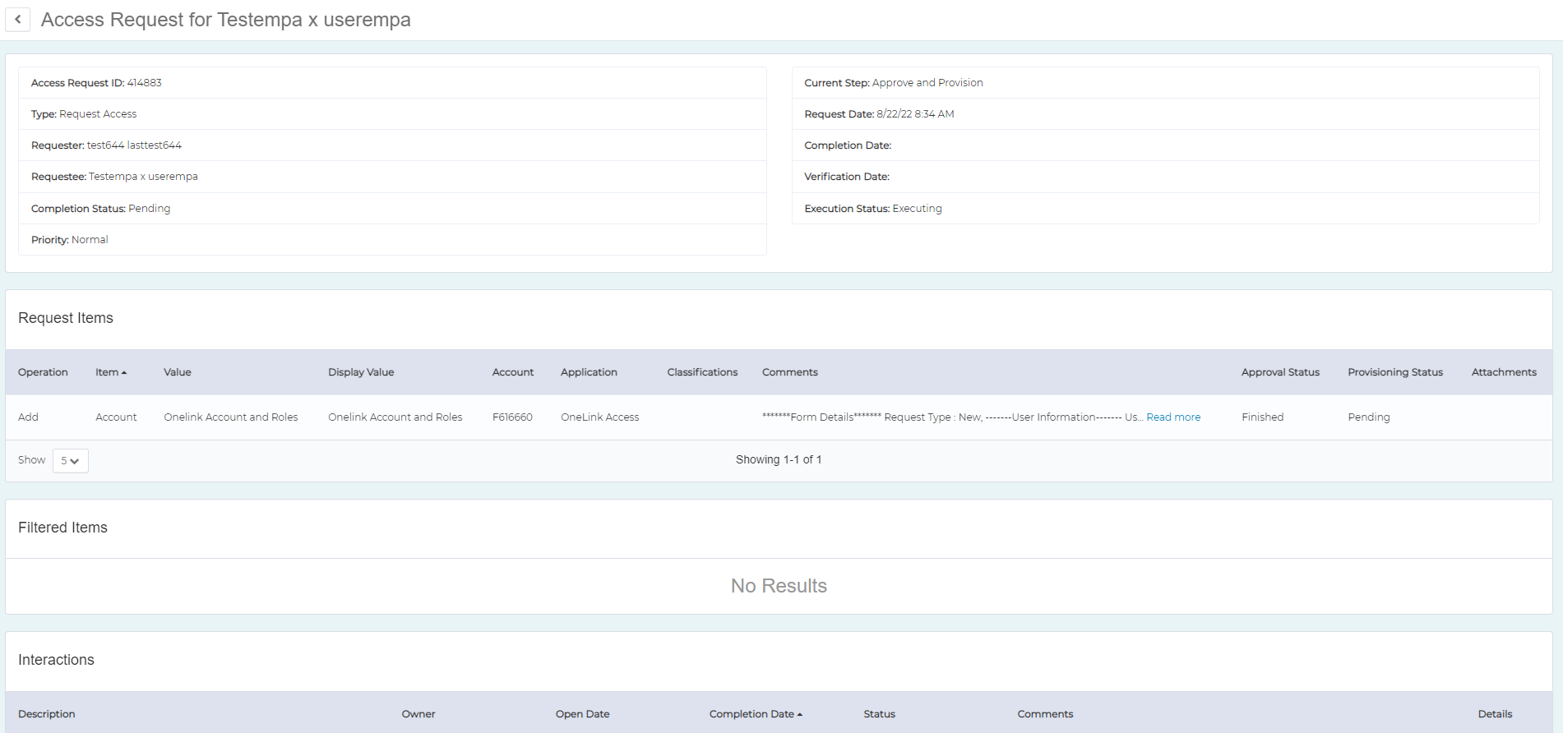  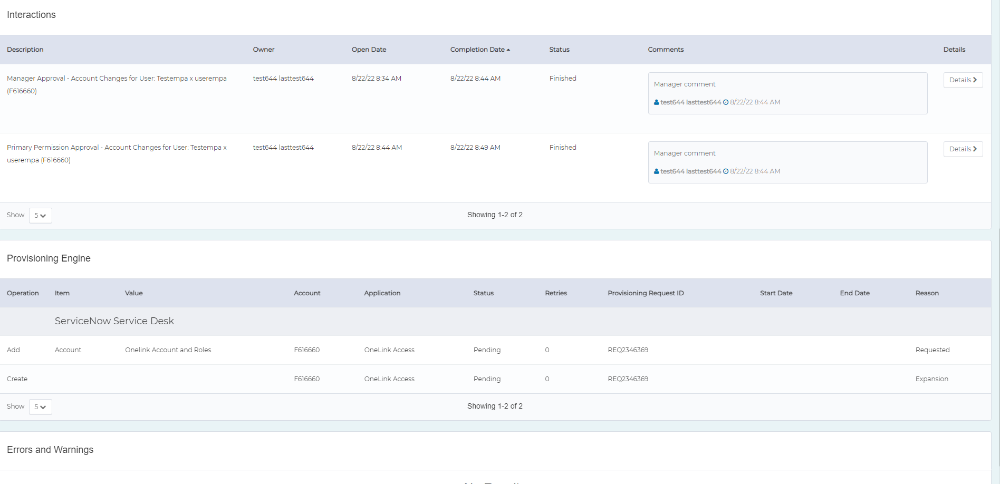

AccessNow Support Resources

AccessNow Resource Page
  - For training, view the right hand column under the section AccessNow Training – Video Training; click on the desired training video.
  - For job aids, view the right-hand column under the section AccessNow Training – Job Aids; click on the desired job aid.
  - For frequently asked questions, click here.
For questions or concerns, please contact AccessNow-Support@kp.org

Defining Common Terms

AccessNow | A new, centralized Identity and Access Management platform based on a market leading solution. It will serve as an entry-point for certifiers to complete access requests.
AccessNow Account | An account that can be associated with a specific user’s KP login ID. The account will include hierarchy, job title, and other information when being reviewed.

