

OneLink Access Request
Access Request

OneLink Access Request
How to request for OneLink Business Role
1

What is AccessNow?
AccessNow is the new Identity and Access Management (IAM) tool that will be replacing KP Identity Manager (KPIM) and Central Review Access Management Application (CARMA). AccessNow will help modernize critical cyber security and risk management capabilities across our business.

- Job Enablement: Provides users with the appropriate level of access to complete their job functions and day-to-day activities.

- Risk Reduction and Security: Helps prevent organizational security risk to sensitive and restricted data by removing access when and where it is no longer appropriate.

- Regulatory Compliance: Access certification is a key control for KP used to monitor and regulate access to applications and databases. This ensures compliance with financial (SOX and PCI) and government (PII) regulatory requirements.

Request OneLink Role in AccessNow

Step # | Description | Screen
Step 1.1 | Navigate to the AccessNow Login Page (formerly KPIM).  Enter NUID and Password Credentials | 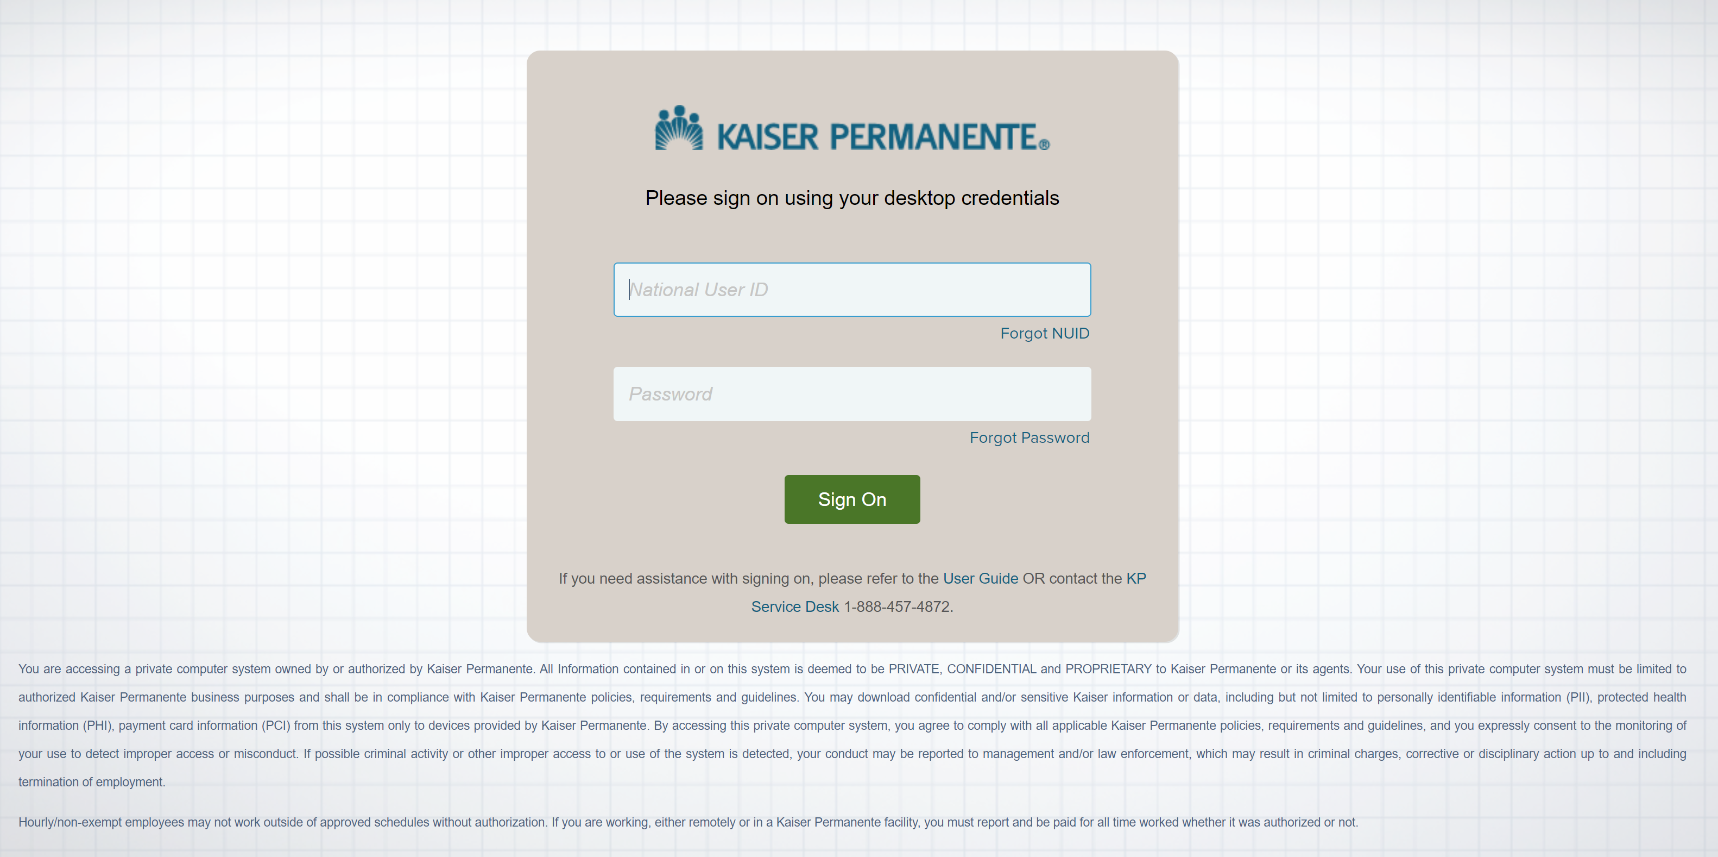
Step 1.2 | From the AccessNow home page, click the icon with three lines on the upper left of the screen.  Click Manage Access from the drop-down options.  Then click Manage Access for Others from the drop-down list. | 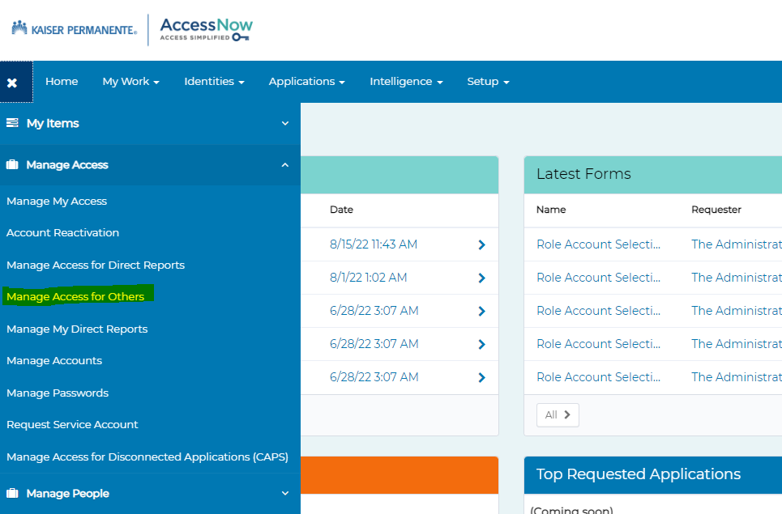
Step 1.3 | Search for the user with NUID or Name select the user and click on Next | 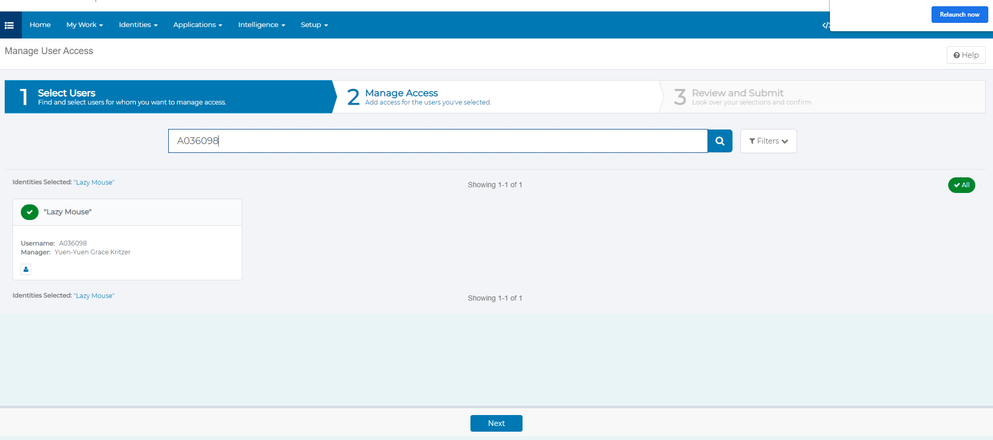
Step 1.4 | Search for “OneLink Access” and click on Filters select Role Type “Business” and click on apply.  It will show you one role, select the role, and click on Next. | 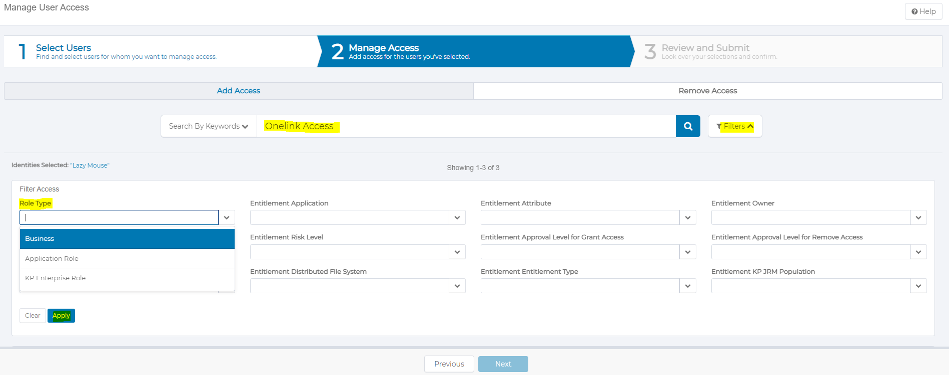  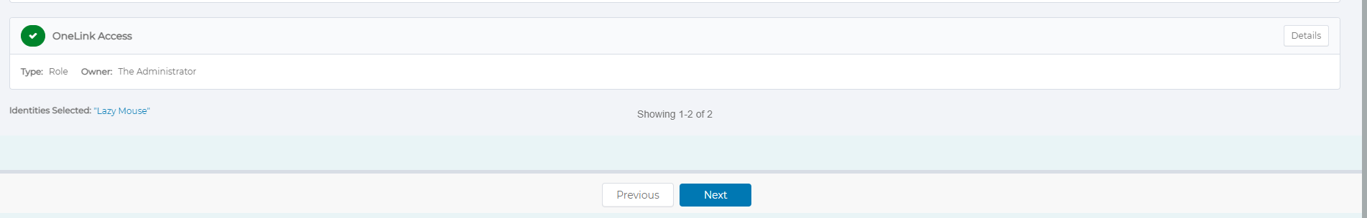
Step 1.5 | Click on attachment icon to upload attachment for your request if desired.  If there no attachment, go to Step 1.8 | 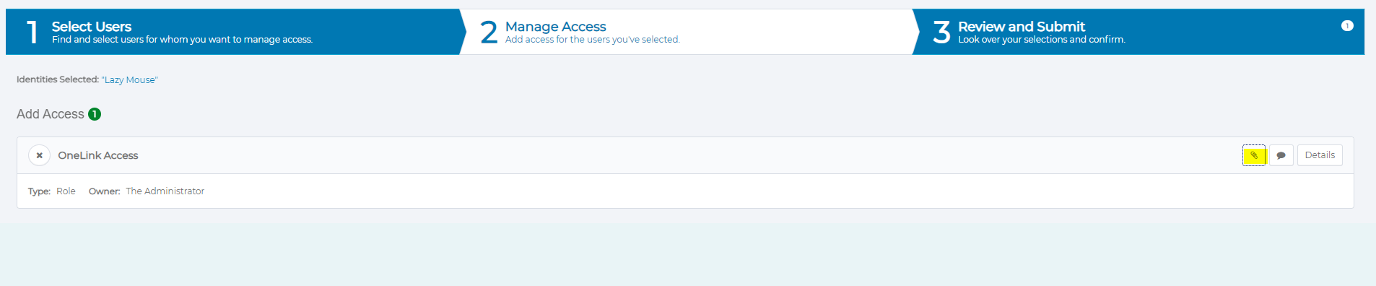  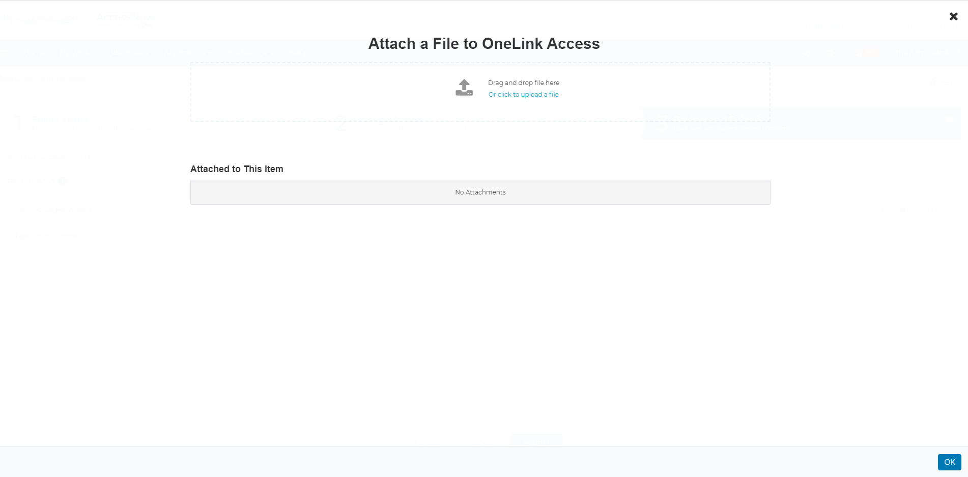
Step 1.6 | If you wish to attach a file, then click on “Click to upload a file” to select the file or you can drag and drop the file. | 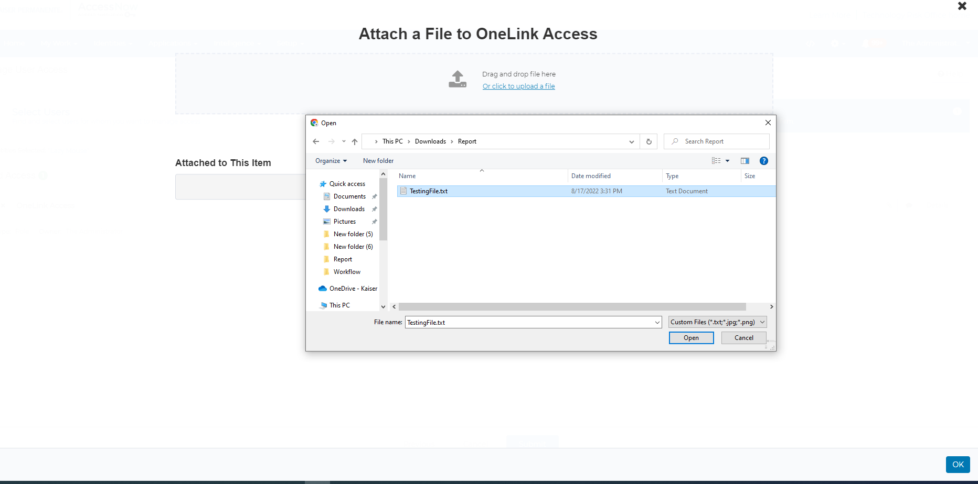
Step 1.7 | You can enter description and delete the uploaded file. Once you are ready click ok. | 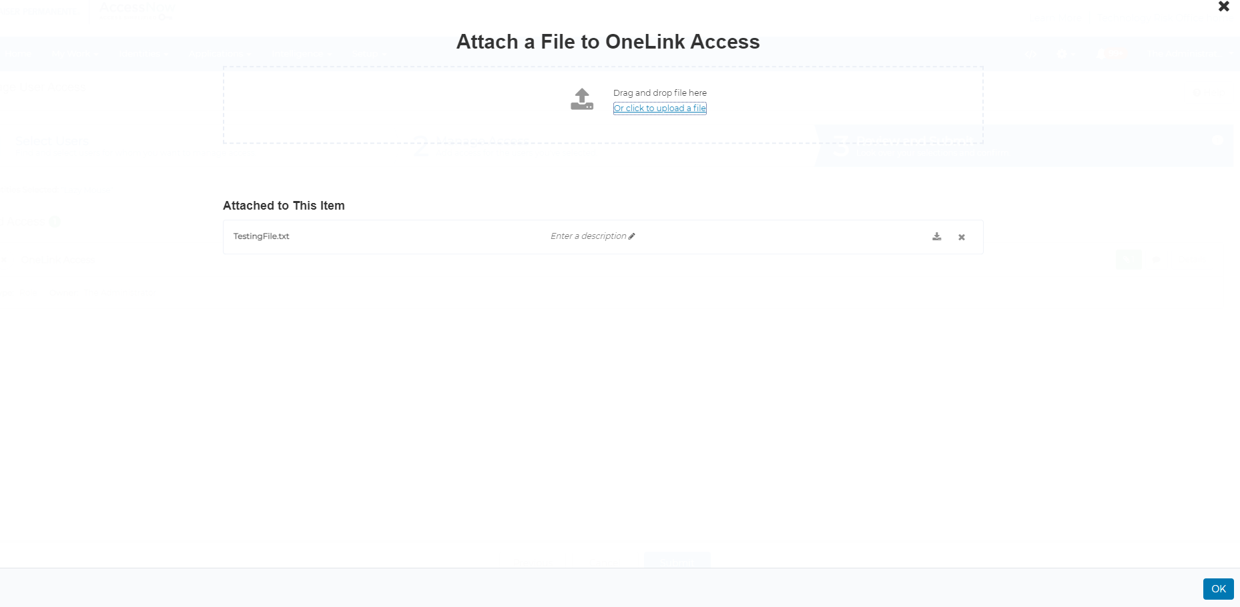
Step 1.8 | Click on submit to submit the request. | 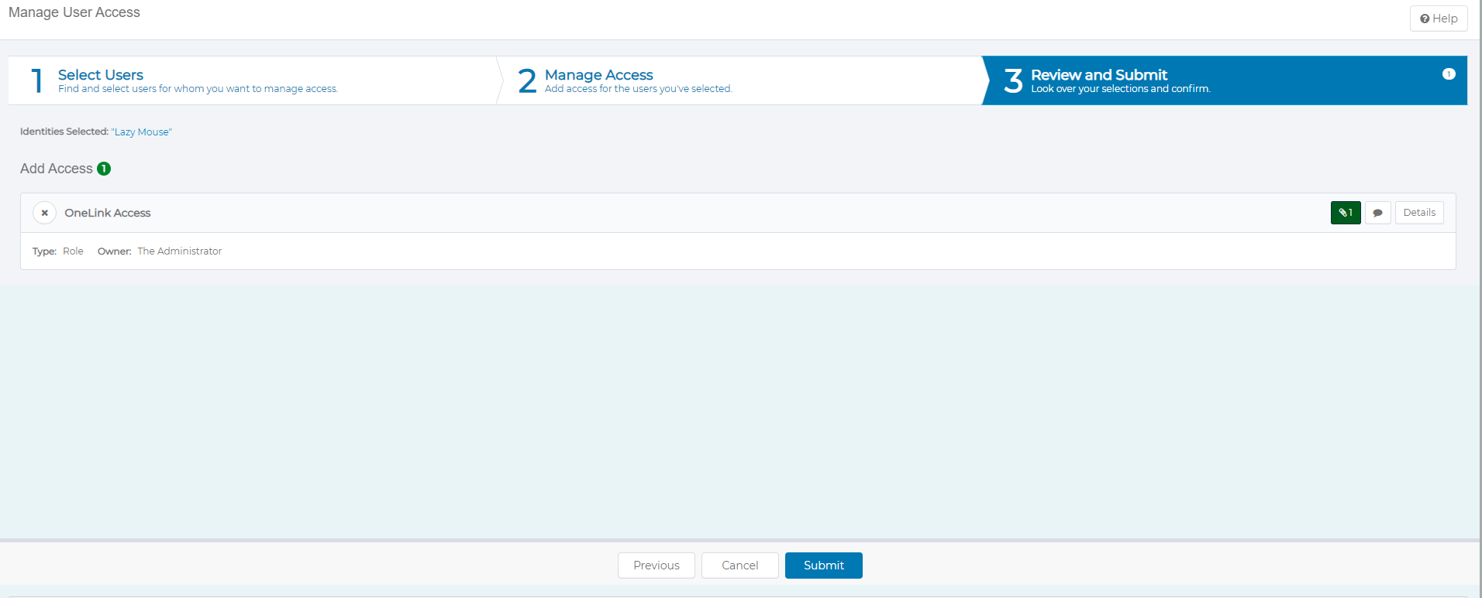
Step 1.9 | A window will appear entitled. “More info needed” Click on the “Complete Form” button to proceed. | 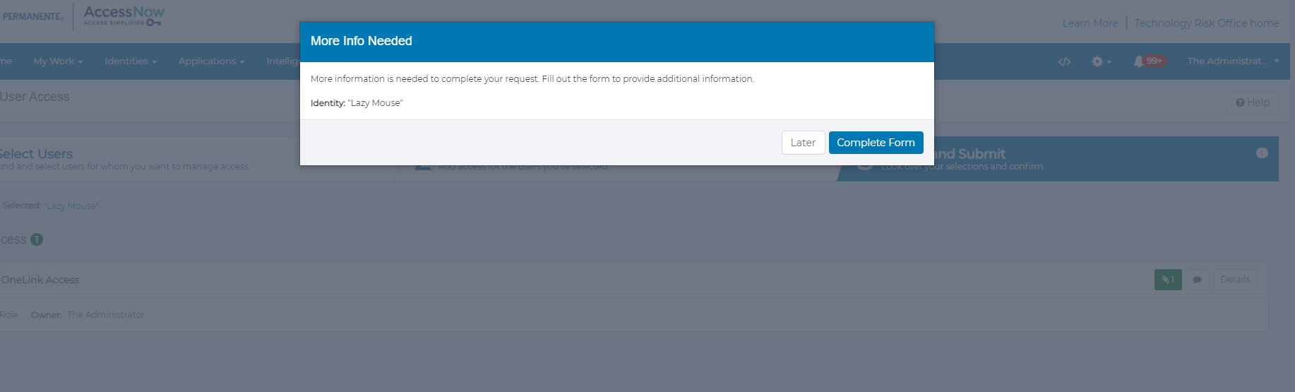
Step 2.0 | Once you click on the “Complete form” buttons, request form details will be displayed on the subsequent window. | 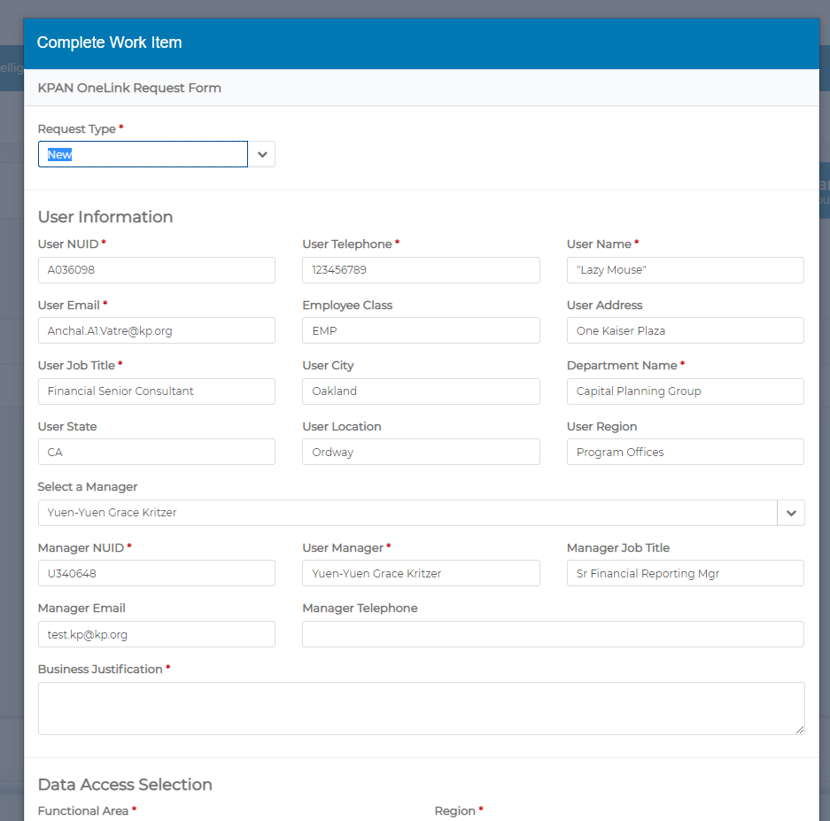
Step 2.1 | User information will be prepopulated if available within AccessNow. If not, mandatory fields marked with a red asterisk must be manually populated with data to proceed further.  If manager information isn’t prepopulated or if the manager shown is not appropriate, please select the appropriate manager. Note, that only valid mangers with direct reports will be available in the drop down.  Enter an appropriate Business Justification in the “Business Justification” field. | 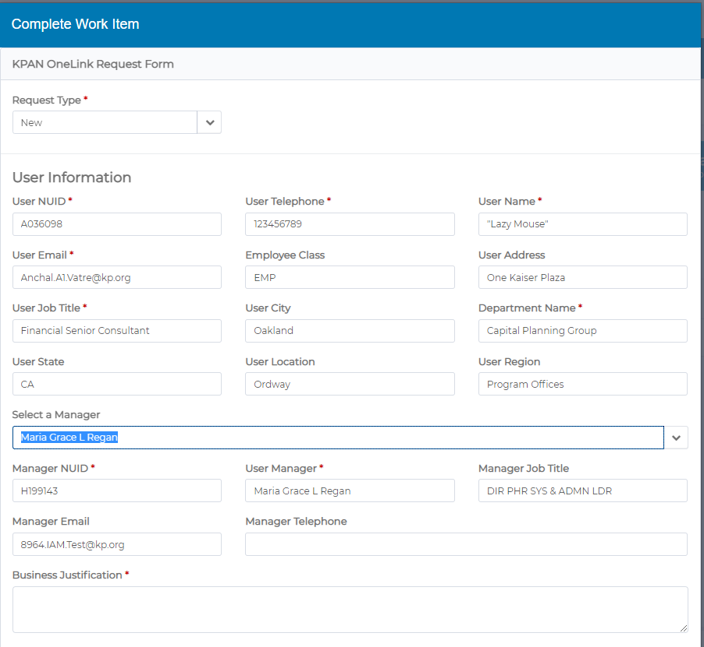
Step 2.2 | Data access selection:  Functional Area, Region, Service Area, and business unit are required fields and dynamic fields. They change based your previous selections.  Check on the Add Primary permission List checkbox to add the Primary Permission list and approvers. | 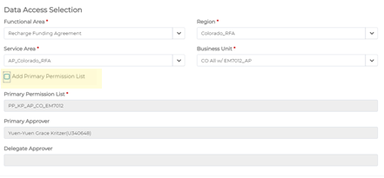
Step 2.3 | Primary job functions:  This is also a mandatory field and dynamic field. The values will be changes based on your previous selections.  Select the primary job function from the drop-down list and click on check box “Insert Job function. Note that multiple primary job functions may be selected in this manner. | 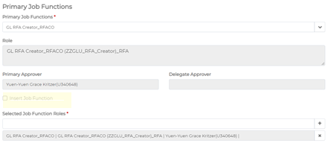
Step 2.4 | There are no additional roles available on Recharge Funding Agreement form. | 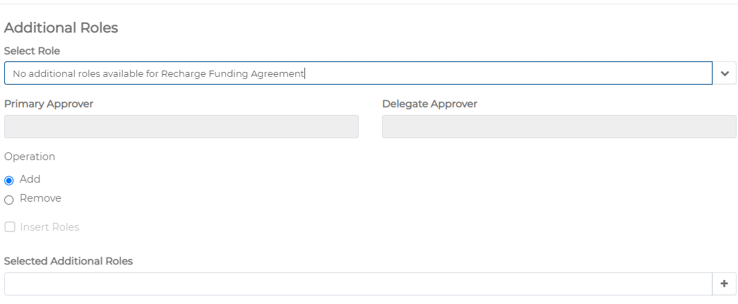
Step 2.7 | Note that a separate BU selection is required for most RFA roles. A section called “Required Roles” will dynamically appear after your role selections are completed. Please choose an appropriate Business Unit from selections in the drop down list. Note that these selections determine which BU’s you will be able to access as either RFA creator or Receiver Reviewer. You can select more than one Business Unit if needed.
Step 2.8 | If there are any segregation of duties will be show in the Migrating control of segregation of duties section this is a read only section. | 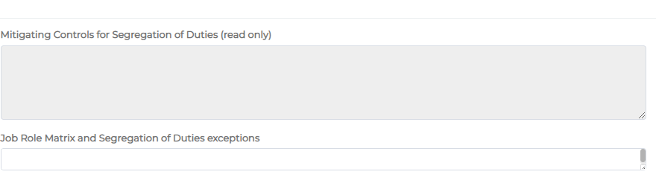
Step 2.9 | Additional comments can be added to your request from “Additional comment” section. | 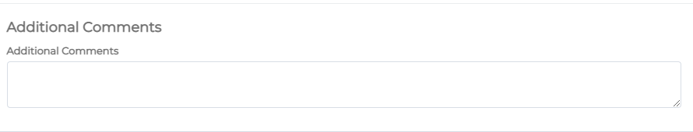
Step 2.9A | Click on next to proceed. If any fields need to be corrected either because of missing data or incorrectly formatted entries, an error message will be displayed indicating that you must correct the flagged entry before proceeding. | 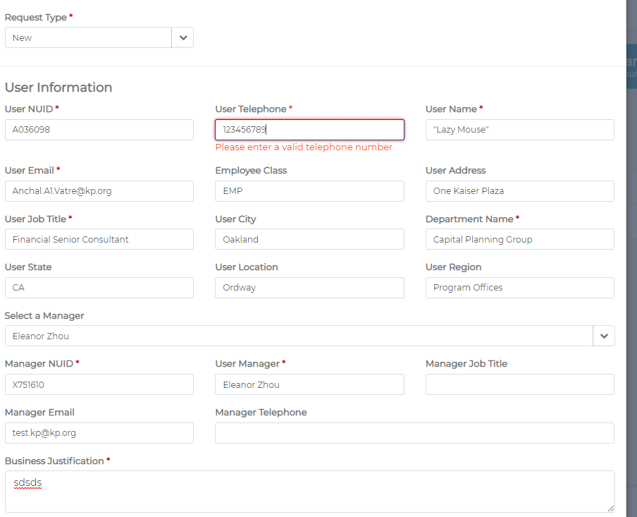
Step 3.0 | Preview form:  If all the entered details are correct and request field are filled, then it will show you a preview form. You can validate entered details/ requested roles. You can continue by clicking “Submit” or you can click on “Back” button to go back to the form and make changes. Clicking on Cancel will terminate the request. | 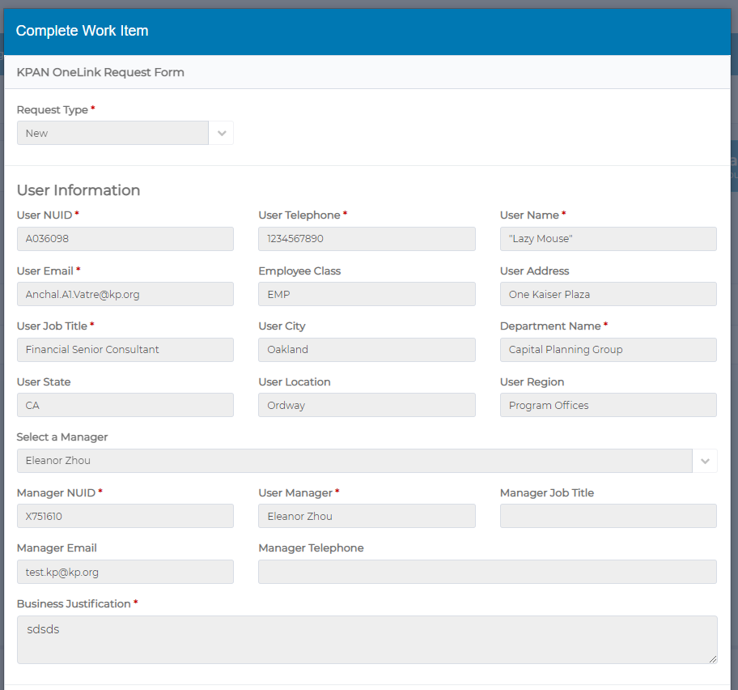  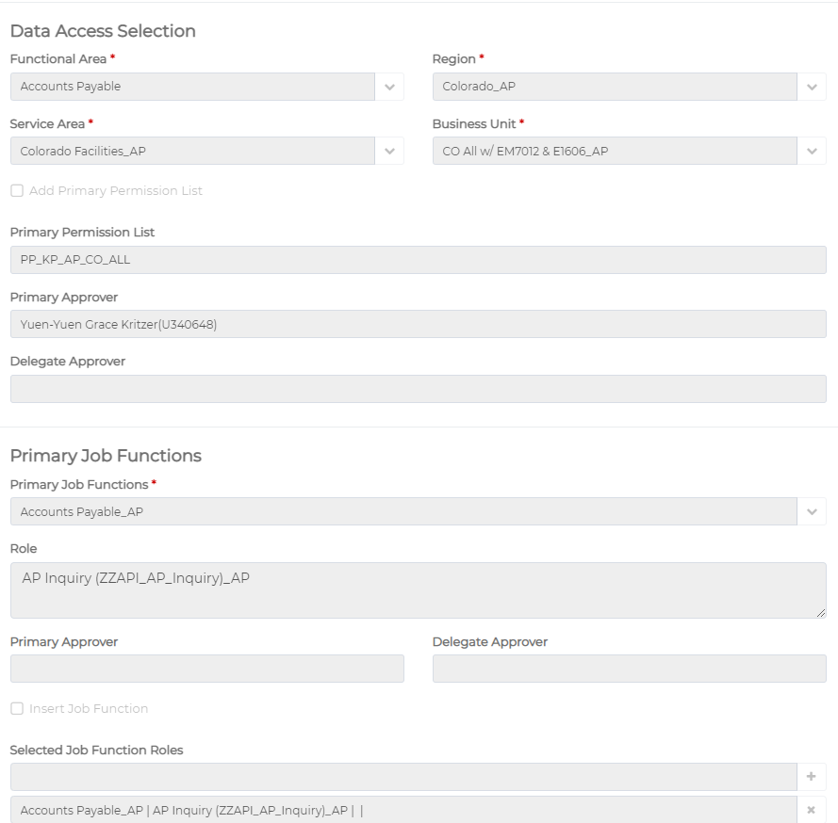  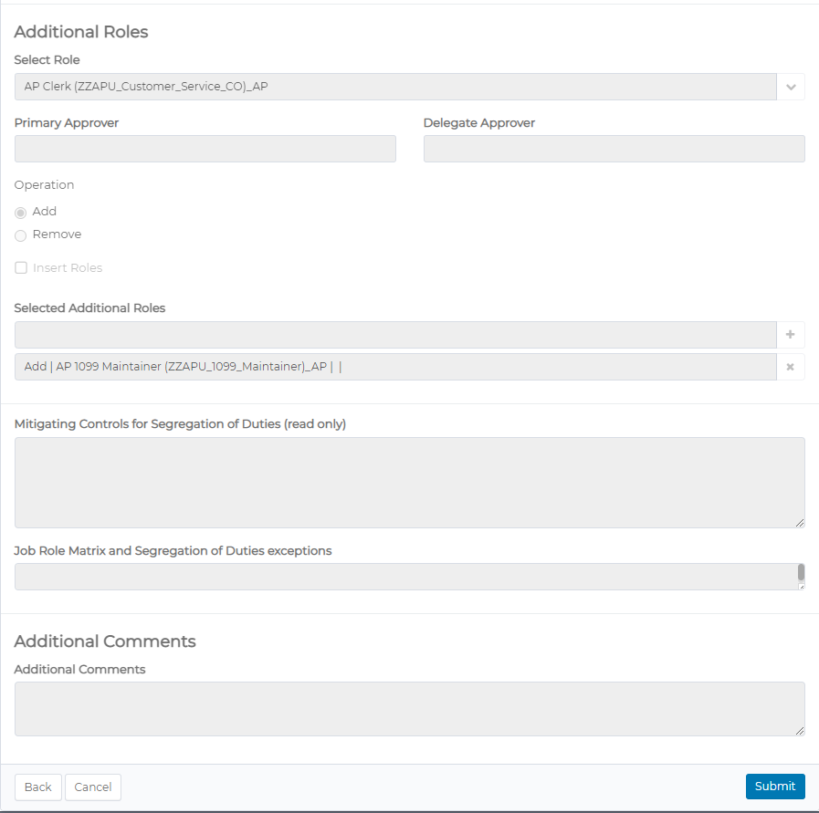
Step 3.1 | If you click on Submit, the request will be submitted, and it will show you a confirmation message.  Click on “ok” to complete the request. | 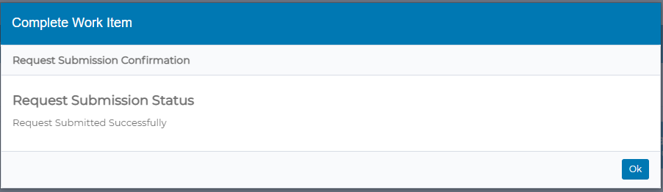
Step 3.2 | If you got My Work and Access Requests, you could check the status of your requests. | 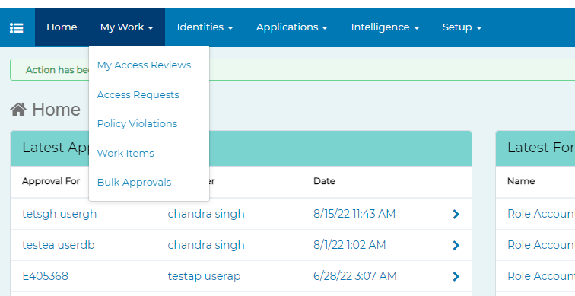  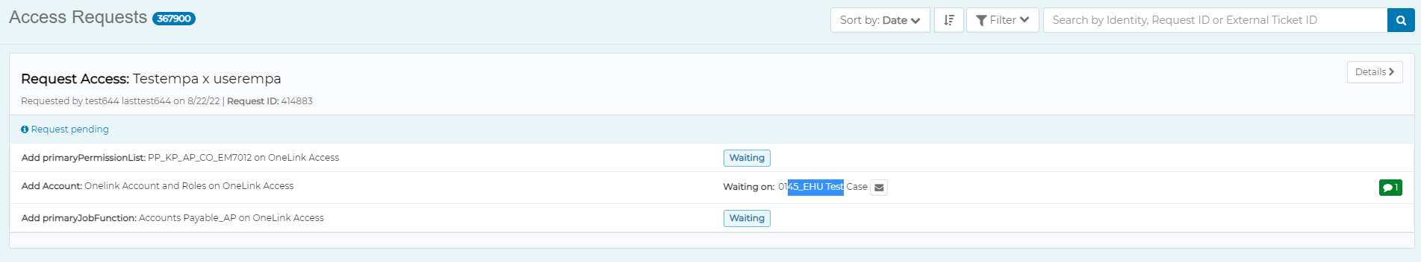
Step 3.3 | AccessNow will also send an email to you as confirmation that your request has been submitted | 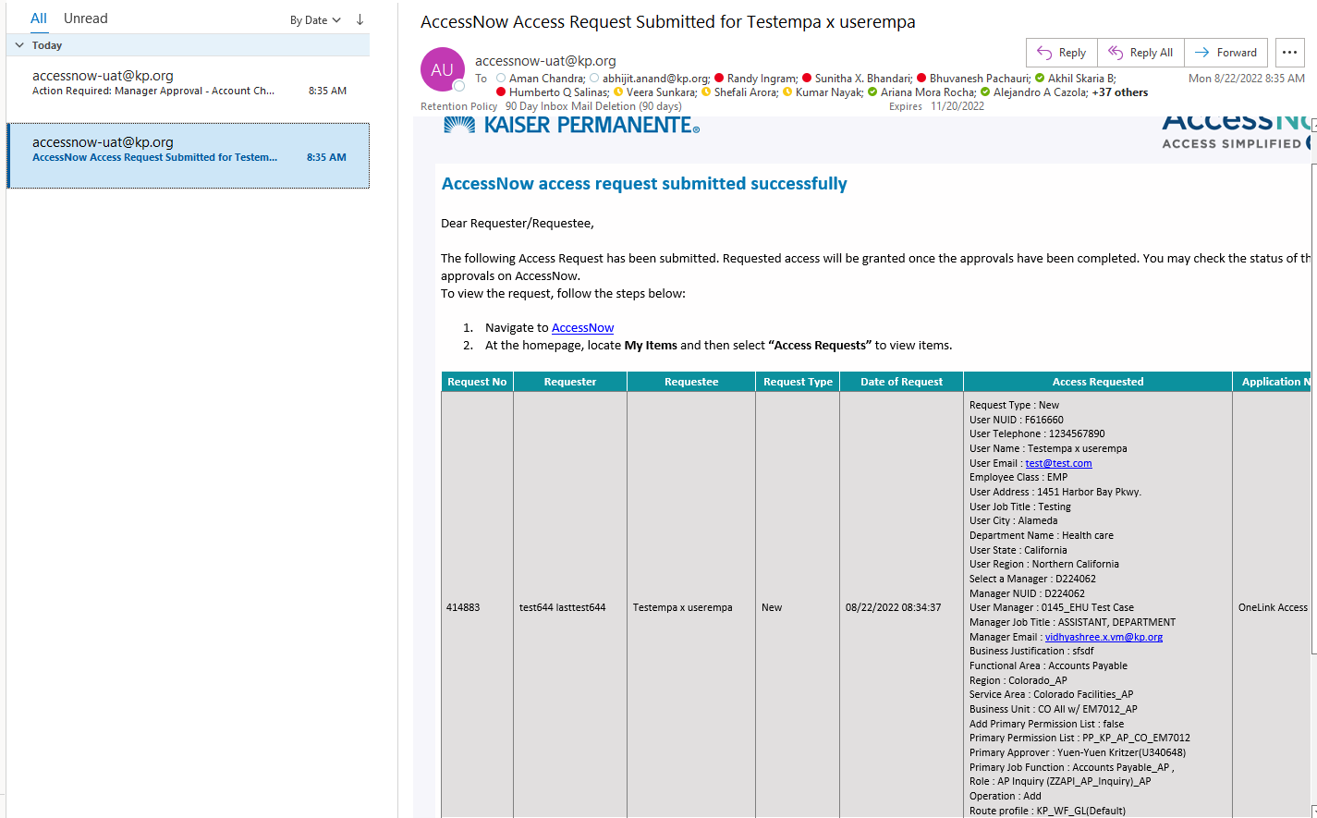
Step 3.4 | If the requester is not the same person as the manager, AccessNow will send an approval work item to approve the request along with an email notification | 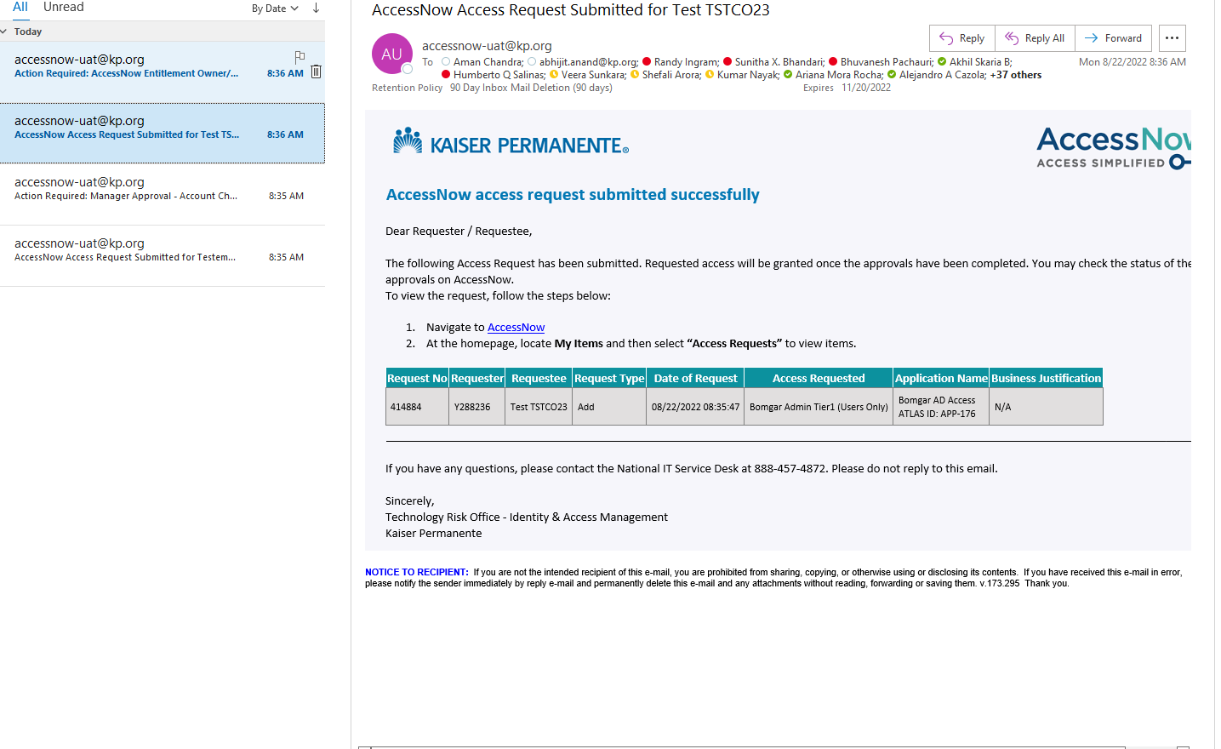  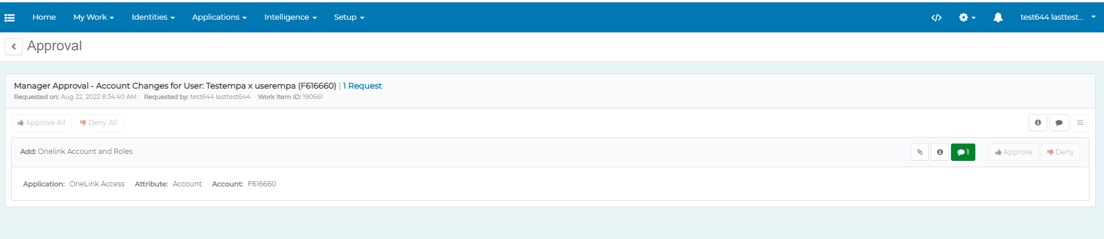
Step 3.5 | Manager Approval:  Manager will login with his/her credentials and click on Approve to approve the request and “Complete” to complete the workitem.  In order to approve the request, however, comments are mandatory. Manager can add comments by clicking the message icon on the approval item | 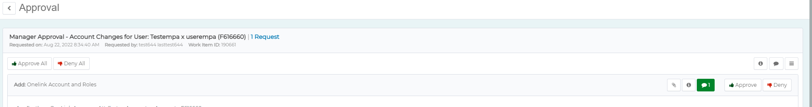  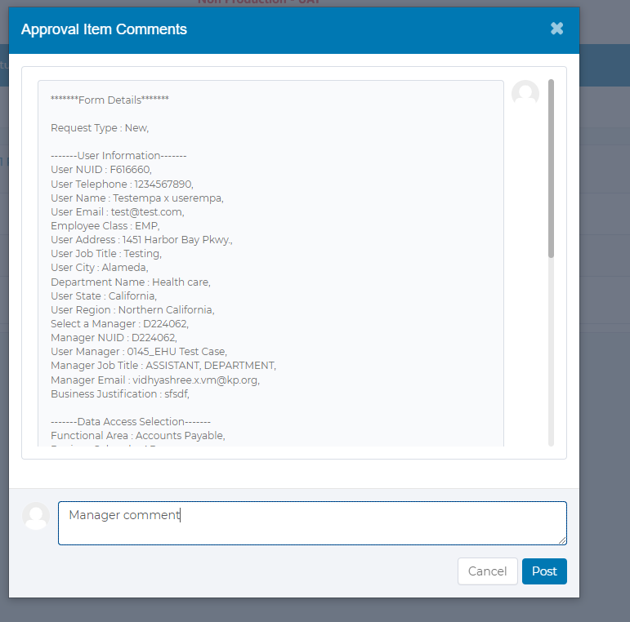  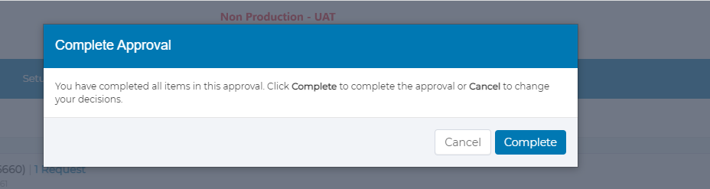
Step 3.6 | Once the manager approval is complete, respective PPL and PJF approvers will be notified along with workitem to approve the request. | 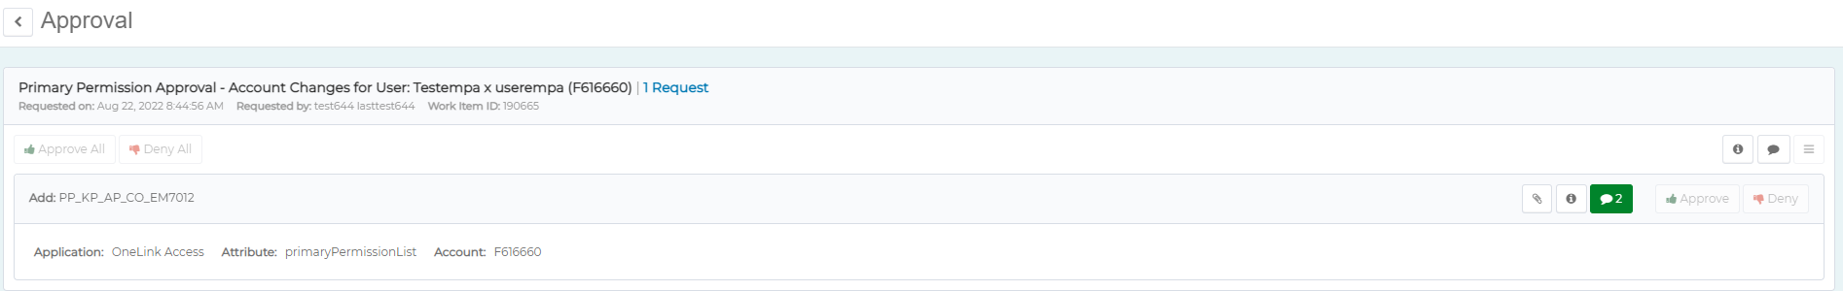  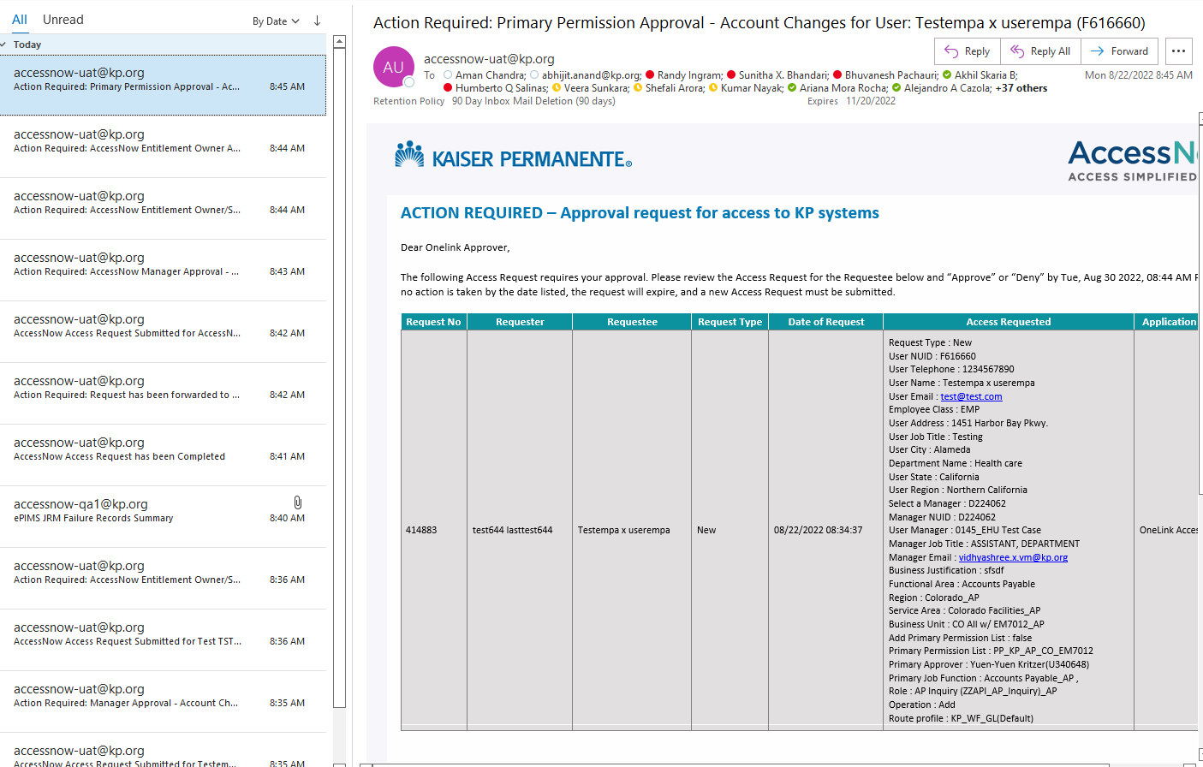
Step 3.7 | PPL and PJF approvers can login and approver the request same as manager. | 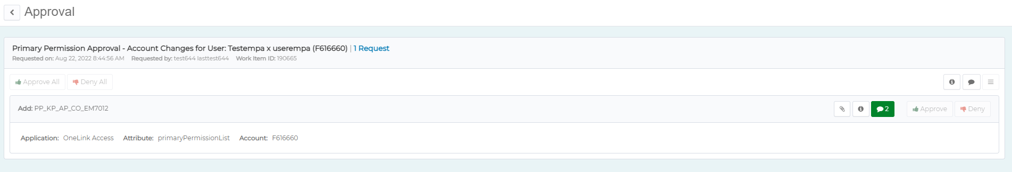
Step 3.8 | Once all the requests are completed requester will be notified with an email of completion of request. Additionally, you can view the ServiceNow ticket in the access request. | 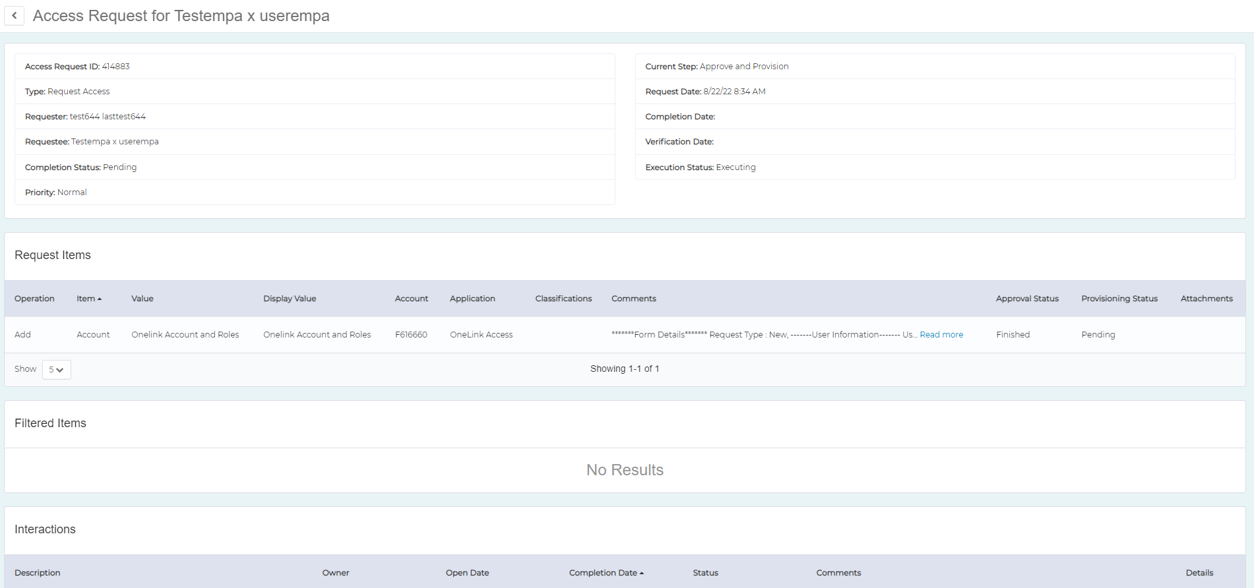  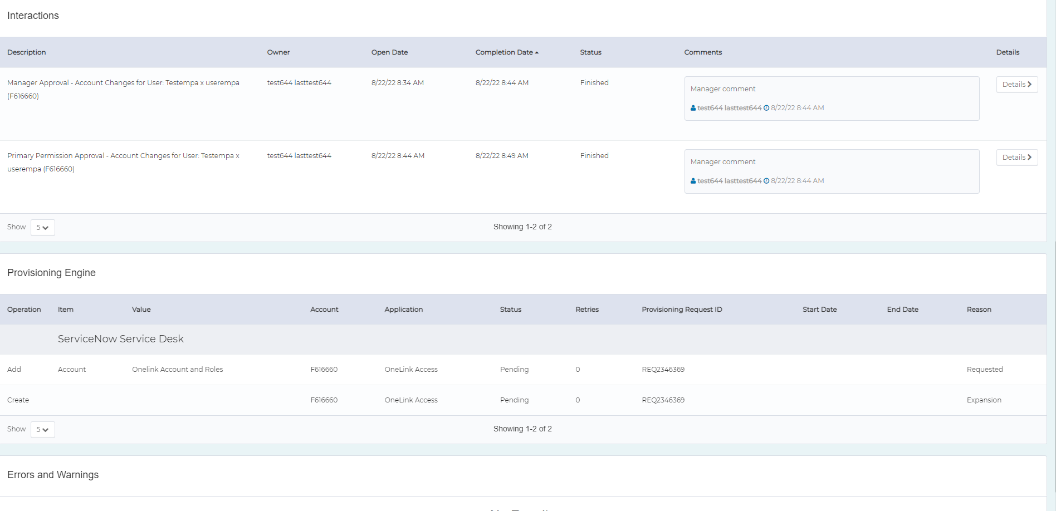

AccessNow Support Resources

AccessNow Resource Page
  - For training, view the right hand column under the section AccessNow Training – Video Training; click on the desired training video.
  - For job aids, view the right-hand column under the section AccessNow Training – Job Aids; click on the desired job aid.
  - For frequently asked questions, click here.
For questions or concerns, please contact AccessNow-Support@kp.org

Defining Common Terms

AccessNow | A new, centralized Identity and Access Management platform based on a market leading solution. It will serve as an entry-point for certifiers to complete access requests.
AccessNow Account | An account that can be associated with a specific user’s KP login ID. The account will include hierarchy, job title, and other information when being reviewed.

