How to Run a Query in OneLink Query Viewer
This job aid covers how to run a query in OneLink Query Viewer.
Query Overview:
- A great way to extract data for analysis in Excel
Results are returned in a grid format (columns and rows)
- Can be used to pull data for any module
- Public queries are created by the OL Production Team
- Many useful queries already exist
- Most OL users have access to run queries. The role needed to run queries in Query Viewer
- Data is real time

- One the OneLink Homepage, select Reporting>Query Viewer
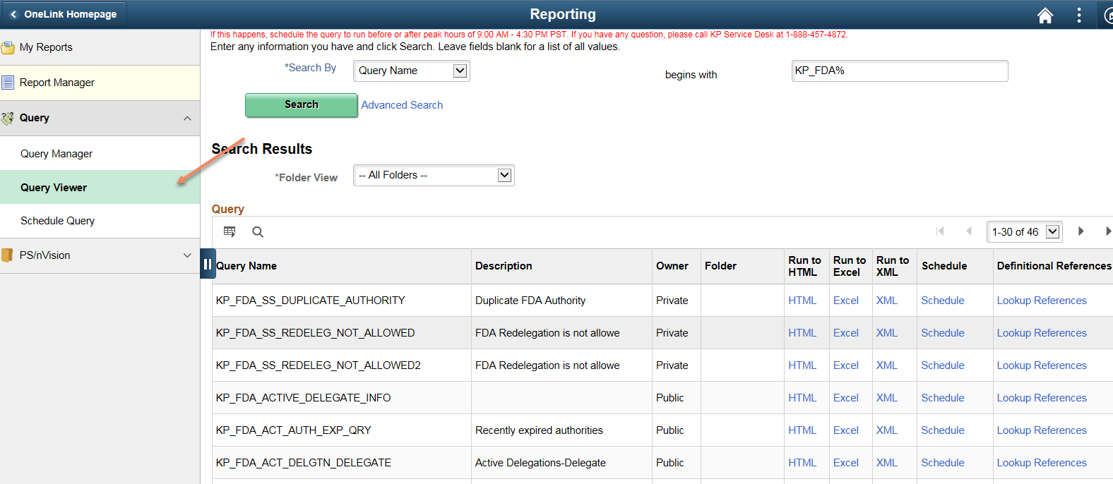
- Enter part, or all, of the query name in the begins with field and click the search button.
  - Note: KP uses a standard naming convention for queries. All queries begin with “KP_” followed by two letters for the module.
  - Tips:
    - You can search for queries by Description by clicking on the “Search By” drop down icon.
    - You can use a “%” as a wild card in your searches such as “%Vouchers%”.
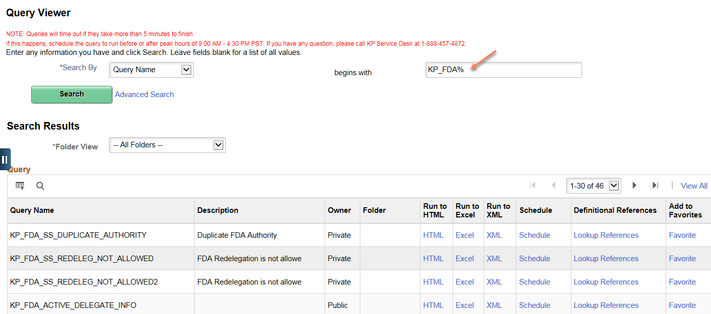
    - You can run the query named KP_Queries to see a list of available queries by module.

- Click on Run to HTML or Run to Excel link.
  - Tips:
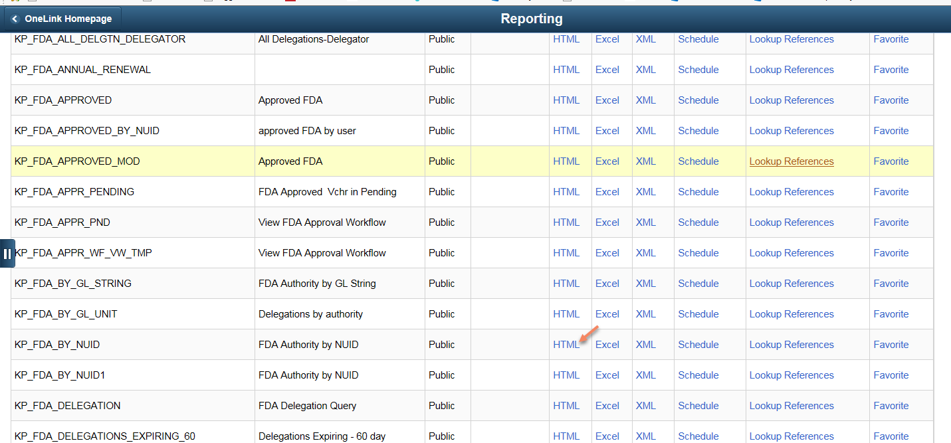
    - A prompt with a “%” in the description means you can enter “%” as wildcard: the query will return all values for that field in the search results. Alternatively, you can enter a specific value in that field to narrow the results.

- When prompted to Open or Save, click Save (for Excel only).
- Complete the prompts and click View Results.
